**VISVESVARAYA TECHNOLOGICAL UNIVERSITY**

**“JnanaSangama”, Belgaum -590014, Karnataka.**



**LAB REPORT**

**On**

**DATA STRUCTURES (23CS3PCDST)**

**Submitted by**

**Arjun Mallikarjun Banappanavar (1BM24CS052)**

**in partial fulfillment for the award of the degree of BACHELOR OF ENGINEERING**

**in**

**COMPUTER SCIENCE AND ENGINEERING**



**B.M.S. COLLEGE OF ENGINEERING**

**(Autonomous Institution under VTU) BENGALURU-560019**

**August-December 2025**

**B. M. S. College of Engineering,**

**Bull Temple Road, Bangalore 560019**

**(Affiliated To Visvesvaraya Technological University, Belgaum) Department of Computer Science and Engineering**



This is to certify that the Lab work entitled **“DATA STRUCTURES”** carried out by Arjun Mallikarjun Banappanavar **(1BM24CS052)**, who is bonafide student of **B. M. S. College of Engineering**. It is in partial fulfillment for the award of **Bachelor of Engineering in Computer Science and Engineering** of the Visvesvaraya Technological University, Belgaum during the year 2025-2026. The Lab report has been approved as it satisfies the academic requirements in respect of Data structures Lab - **(23CS3PCDST)** work prescribed for the said degree.

**Ms. Manjula S Dr. Kavitha Sooda**

Assistant Professor Professor and Head

Department of ISE Department of CSE

BMSCE, Bengaluru BMSCE, Bengaluru

**Index Sheet**

|  |  |  |
| --- | --- | --- |
| **Sl.**  **No.** | **Experiment Title** | **Page No.** |
| 1 | Stack Operations | 5 |
| 2 | Infix to Postfix Expression | 9 |
| 3 | Queue and Circular Queue Operations | 12 |
| 4 | Singly Linked List Operations | 20 |
| 5 | Singly Linked List Deletion Operations | 25 |
| 6 | Sort, Reverse, Concatenate Singly Linked List Operations and Stack and Queue Implementation using Linked List | 31 |
| 7 | Doubly Linked List Operations | 42 |
| 8 | Binary Search Tree creation and traversal (inorder, preorder, postorder) | 49 |
| 9 | Graphs Breadth First Search (BFS) and Depth First Search (DFS) | 54 |
| 10 | Hashing Problem | 59 |

**Course outcomes:**

|  |  |
| --- | --- |
| CO1 | Apply the concept of linear and nonlinear data structures. |
| CO2 | Analyze data structure operations for a given problem |
| CO3 | Design and develop solutions using the operations of linear and nonlinear data structure for a given specification. |
| CO4 | Conduct practical experiments for demonstrating the operations of different data structures. |

# Program 1:

**Write a program to simulate the working of stack using an array with the following:**

1. **a) Push**
2. **b) Pop**
3. **c) Display**

**The program should print appropriate messages for stack overflow, stack underflow.**

**Code:**

#include <stdio.h> #include <stdlib.h>

#define SIZE 10

int stack[SIZE]; int top = -1;

void push(int value) { if (top == SIZE - 1) {

printf("Stack Overflow\n");

} else {

stack[++top] = value; printf("Inserted %d\n", value);

}

}

void pop() {

if (top == -1) {

printf("Stack Underflow\n");

} else {

printf("Deleted %d\n", stack[top--]);

}

}

void display() { if (top == -1) {

printf("Stack is Empty\n");

} else {

for (int i = top; i >= 0; i--) {

printf("%d ", stack[i]);

}

printf("\n");

}

}

void peek() {

if (top == -1) {

printf("Stack is Empty\n");

} else {

printf("Top element is %d\n", stack[top]);

}

}

int main() {

int choice, value; do {

printf("\n1.Push 2.Pop 3.Display 4.Peek 5.Exit\n"); scanf("%d", &choice);

switch (choice) { case 1:

scanf("%d", &value); push(value);

break;

case 2:

pop(); break;

case 3:

display(); break;

case 4:

peek(); break;

case 5:

break; default:

printf("Invalid Choice\n");

}

}while(choice != 5);

return 0;

}

**Output:**

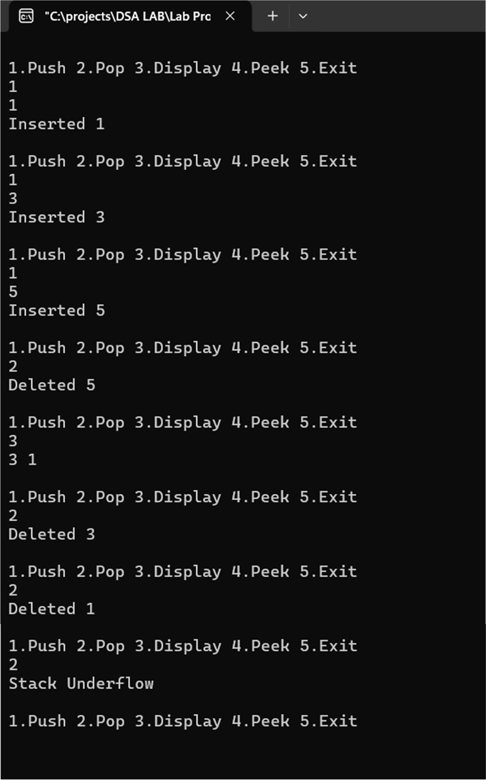

# Program 2:

**WAP to convert a given valid parenthesized infix arithmetic expression to postfix expression. The expression consists of single character operands and the binary operators + (plus), - (minus), * (multiply) and / (divide)**

**Code:**

**#include <stdio.h> #include <ctype.h>**

**#define SIZE 50**

**char stack[SIZE]; int top = -1;**

**void push(char x) { stack[++top] = x;**

**}**

**char pop() {**

**return stack[top--];**

**}**

**int pr(char x) {**

**if (x == '+' || x == '-') return 1;**

**if (x == '*' || x == '/') return 2;**

**return 0;**

**}**

**int main() {**

**char infix[50], postfix[50], ch; int i = 0, k = 0;**

**printf("enter infix:"); scanf("%s", infix);**

**push('#');**

**while ((ch = infix[i++]) != '\0') { if (ch == '(')**

**push(ch);**

**else if (isalnum(ch)) postfix[k++] = ch;**

**else if (ch == ')') {**

**while (stack[top] != '(') postfix[k++] = pop();**

**pop();**

**} else {**

**while (pr(stack[top]) >= pr(ch)) postfix[k++] = pop();**

**push(ch);**

**}**

**}**

**while (stack[top] != '#') postfix[k++] = pop();**

**postfix[k] = '\0'; printf("%s", postfix);**

**return 0;**

**}**

**Output:**

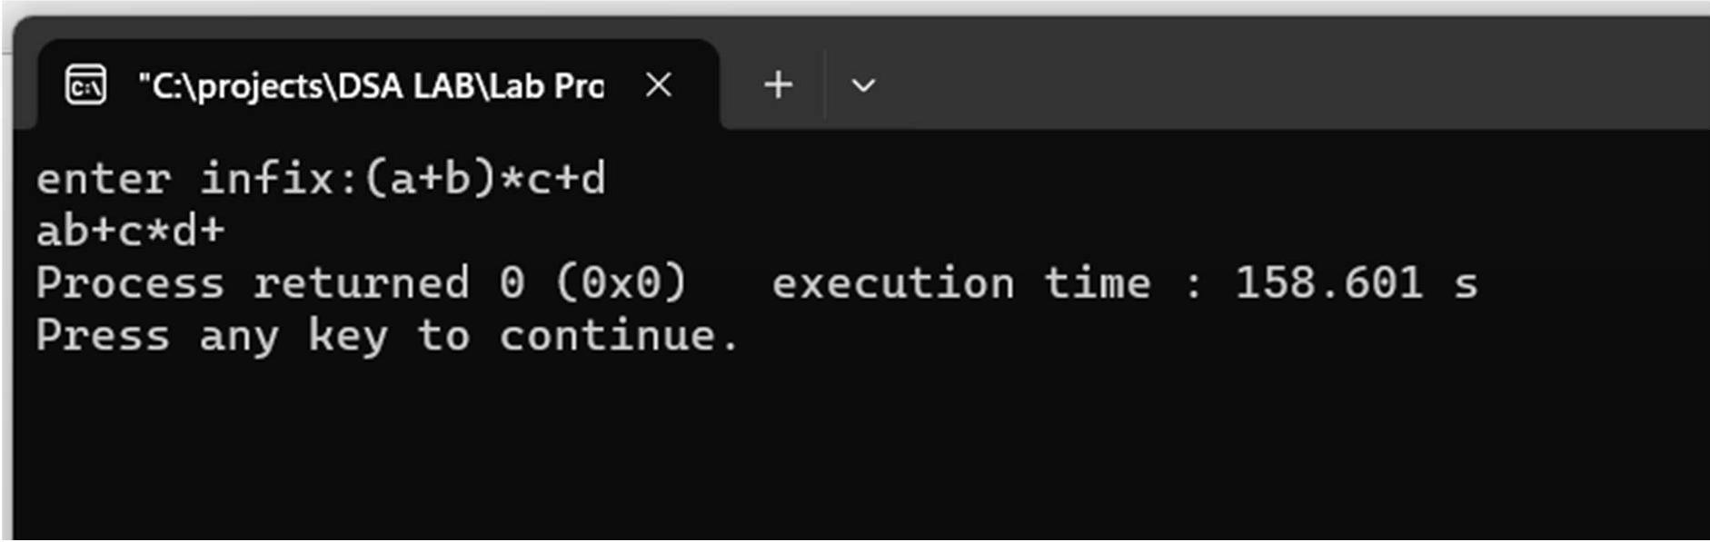

# Program 3a:

1. **WAP to simulate the working of a queue of integers using an array. Provide the following operations: Insert, Delete, Display The program should print appropriate messages for queue empty and queue overflow conditions.**

**Code:**

**#include <stdio.h> #define MAX 50**

**int q[MAX], front = -1, rear = -1;**

**void insert() { int x;**

**if (rear == MAX - 1) { printf("Queue Overflow\n"); return;**

**}**

**if (front == -1) front = 0;**

**printf("Enter element: "); scanf("%d", &x); q[++rear] = x; printf("Inserted %d\n", x);**

**}**

**void delete() {**

**if (front == -1 || front > rear) {**

**printf("Queue Underflow\n"); return;**

**}**

**printf("Deleted element: %d\n", q[front]); front++;**

**}**

**void display() { int i;**

**if (front == -1 || front > rear) { printf("Queue is Empty\n"); return;**

**}**

**printf("Queue elements: "); for (i = front; i <= rear; i++)**

**printf("%d ", q[i]); printf("\n");**

**}**

**int main() { int ch; while (1) {**

**printf("\n1.Insert\n2.Delete\n3.Display\n4.Exit\n"); printf("Enter choice: ");**

**scanf("%d", &ch);**

**if (ch == 1) insert();**

**else if (ch == 2) delete();**

**else if (ch == 3) display();**

**else if (ch == 4) break;**

**else**

**printf("Invalid choice\n");**

**}**

**return 0;**

**}**

**Output:**

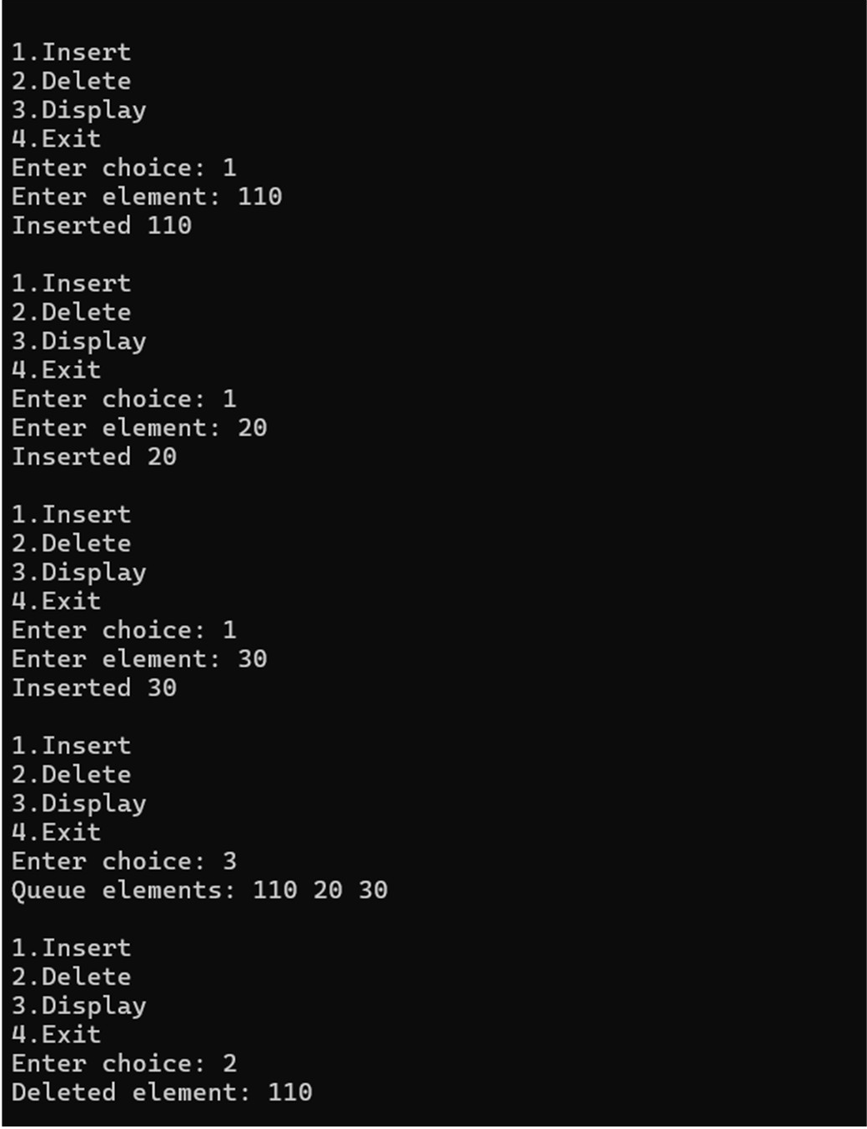

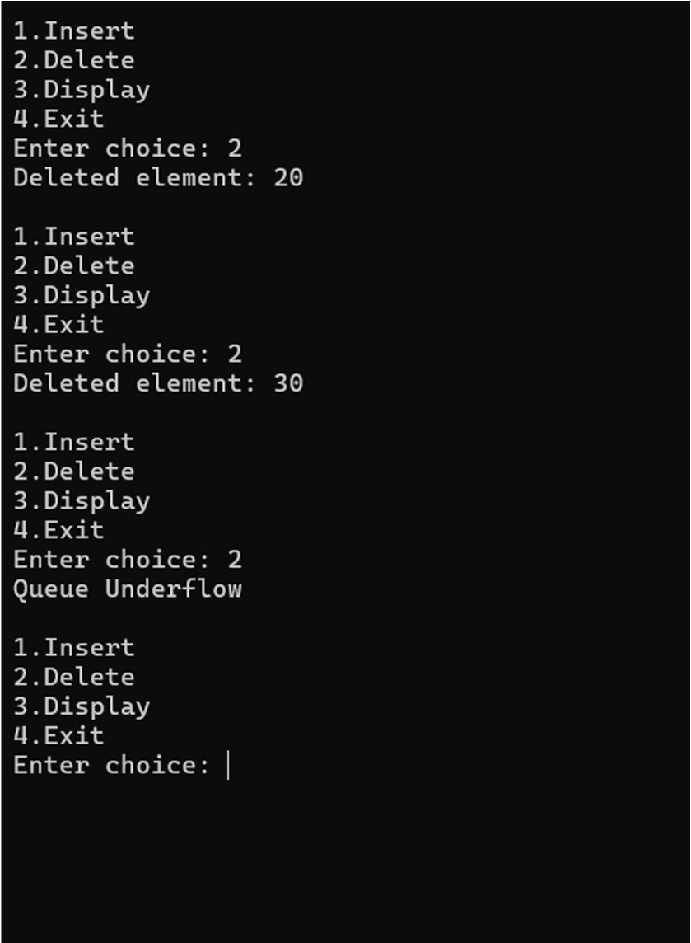

# Program 3b:

1. **WAP to simulate the working of a circular queue of integers using an array. Provide the following operations: Insert, Delete & Display The program should print appropriate messages for queue empty and queue overflow conditions**

**Code:**

#include <stdio.h> #define SIZE 5

int q[SIZE], front = -1, rear = -1;

int isFull() {

return (front == (rear + 1) % SIZE);

}

int isEmpty() { return front == -1;

}

void enqueue(int x) { if (isFull()) {

printf("Queue Overflow\n"); return;

}

if (front == -1) front = 0;

rear = (rear + 1) % SIZE; q[rear] = x; printf("Inserted %d\n", x);

}

void dequeue() {

if (isEmpty()) {

printf("Queue Underflow\n"); return;

}

printf("Deleted element: %d\n", q[front]); if (front == rear)

front = rear = -1; else

front = (front + 1) % SIZE;

}

void display() { int i;

if (isEmpty()) {

printf("Queue is Empty\n"); return;

}

printf("Queue elements: ");

for (i = front; i != rear; i = (i + 1) % SIZE) printf("%d ", q[i]);

printf("%d\n", q[i]);

}

int main() { int ch, x; while (1) {

printf("\n1.Enqueue\n2.Dequeue\n3.Display\n4.Exit\n"); printf("Enter choice: ");

scanf("%d", &ch);

if (ch == 1) {

printf("Enter element: "); scanf("%d", &x); enqueue(x);

}

else if (ch == 2) dequeue(); else if (ch == 3)

display(); else if (ch == 4)

break; else

printf("Invalid choice\n");

}

return 0;

}

**Output:**

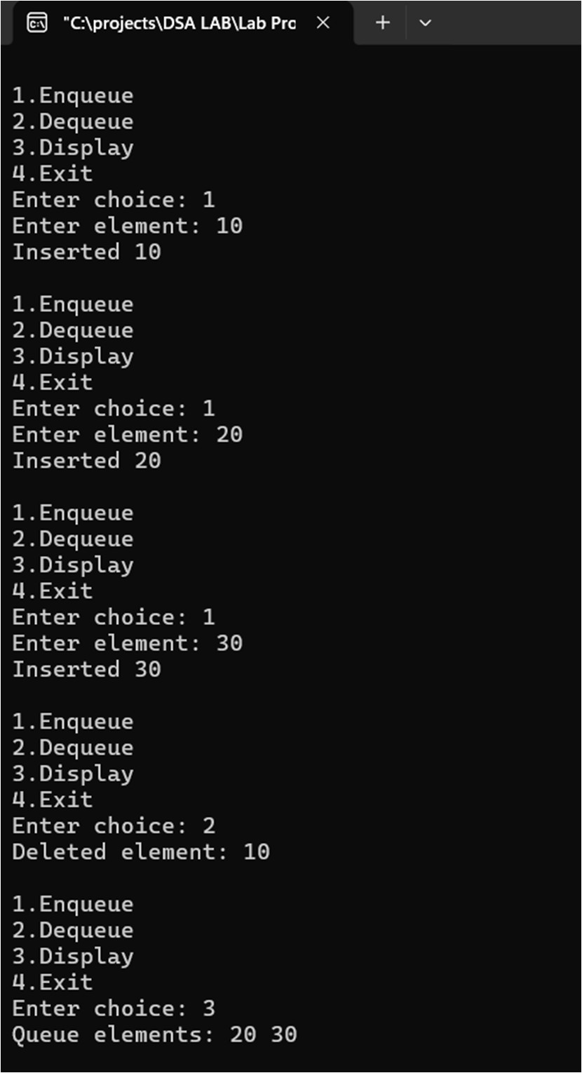

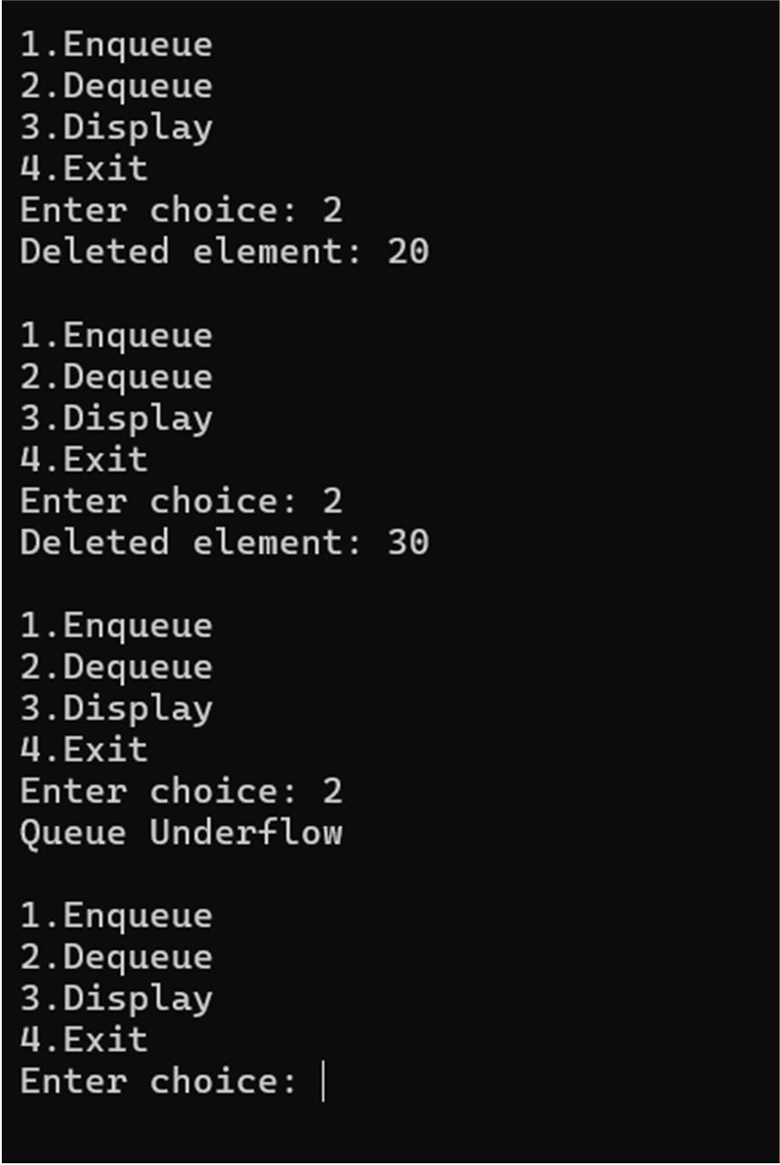

# Program 4:

**WAP to Implement Singly Linked List with following operations a) Create a linked list. b) Insertion of a node at first position, at any position and at end of list. Display the contents of the linked list**

**Code:**

**#include <stdio.h> #include <stdlib.h>**

**struct node { int data;**

**struct node *next;**

**};**

**struct node *head = NULL;**

**struct node* create(int x) {**

**struct node *n = malloc(sizeof(struct node)); if (!n) exit(1);**

**n->data = x;**

**n->next = NULL; return n;**

**}**

**int count() { int c = 0;**

**struct node *t = head; while (t) {**

**c++;**

**t = t->next;**

**}**

**return c;**

**}**

**void insert_begin(int x) { struct node *n = create(x); n->next = head;**

**head = n;**

**printf("Inserted %d at beginning\n", x);**

**}**

**void insert_end(int x) {**

**struct node *n = create(x), *t = head; if (!head) {**

**head = n;**

**printf("Inserted %d as first node\n", x); return;**

**}**

**while (t->next) t = t->next; t->next = n;**

**printf("Inserted %d at end\n", x);**

**}**

**void insert_pos(int x, int pos) { int i;**

**struct node *t = head;**

**if (pos < 1 || pos > count() + 1) { printf("Invalid position\n");**

**return;**

**}**

**if (pos == 1) { insert_begin(x); return;**

**}**

**for (i = 1; i < pos - 1; i++) t = t->next;**

**struct node *n = create(x); n->next = t->next;**

**t->next = n;**

**printf("Inserted %d at position %d\n", x, pos);**

**}**

**void display() {**

**struct node *t = head; if (!t) {**

**printf("List is empty\n"); return;**

**}**

**printf("List: "); while (t) {**

**printf("%d ", t->data); t = t->next;**

**}**

**printf("\n");**

**}**

**int main() {**

**int ch, x, pos; while (1) {**

**printf("\n1.Insert Begin\n2.Insert End\n3.Insert Position\n4.Display\n5.Exit\n"); printf("Enter choice: ");**

**scanf("%d", &ch);**

**if (ch == 1) { scanf("%d", &x); insert_begin(x);**

**}**

**else if (ch == 2) { scanf("%d", &x); insert_end(x);**

**}**

**else if (ch == 3) {**

**scanf("%d %d", &x, &pos); insert_pos(x, pos);**

**}**

**else if (ch == 4) display();**

**else if (ch == 5) break;**

**}**

**return 0;**

**}**

**Output:**

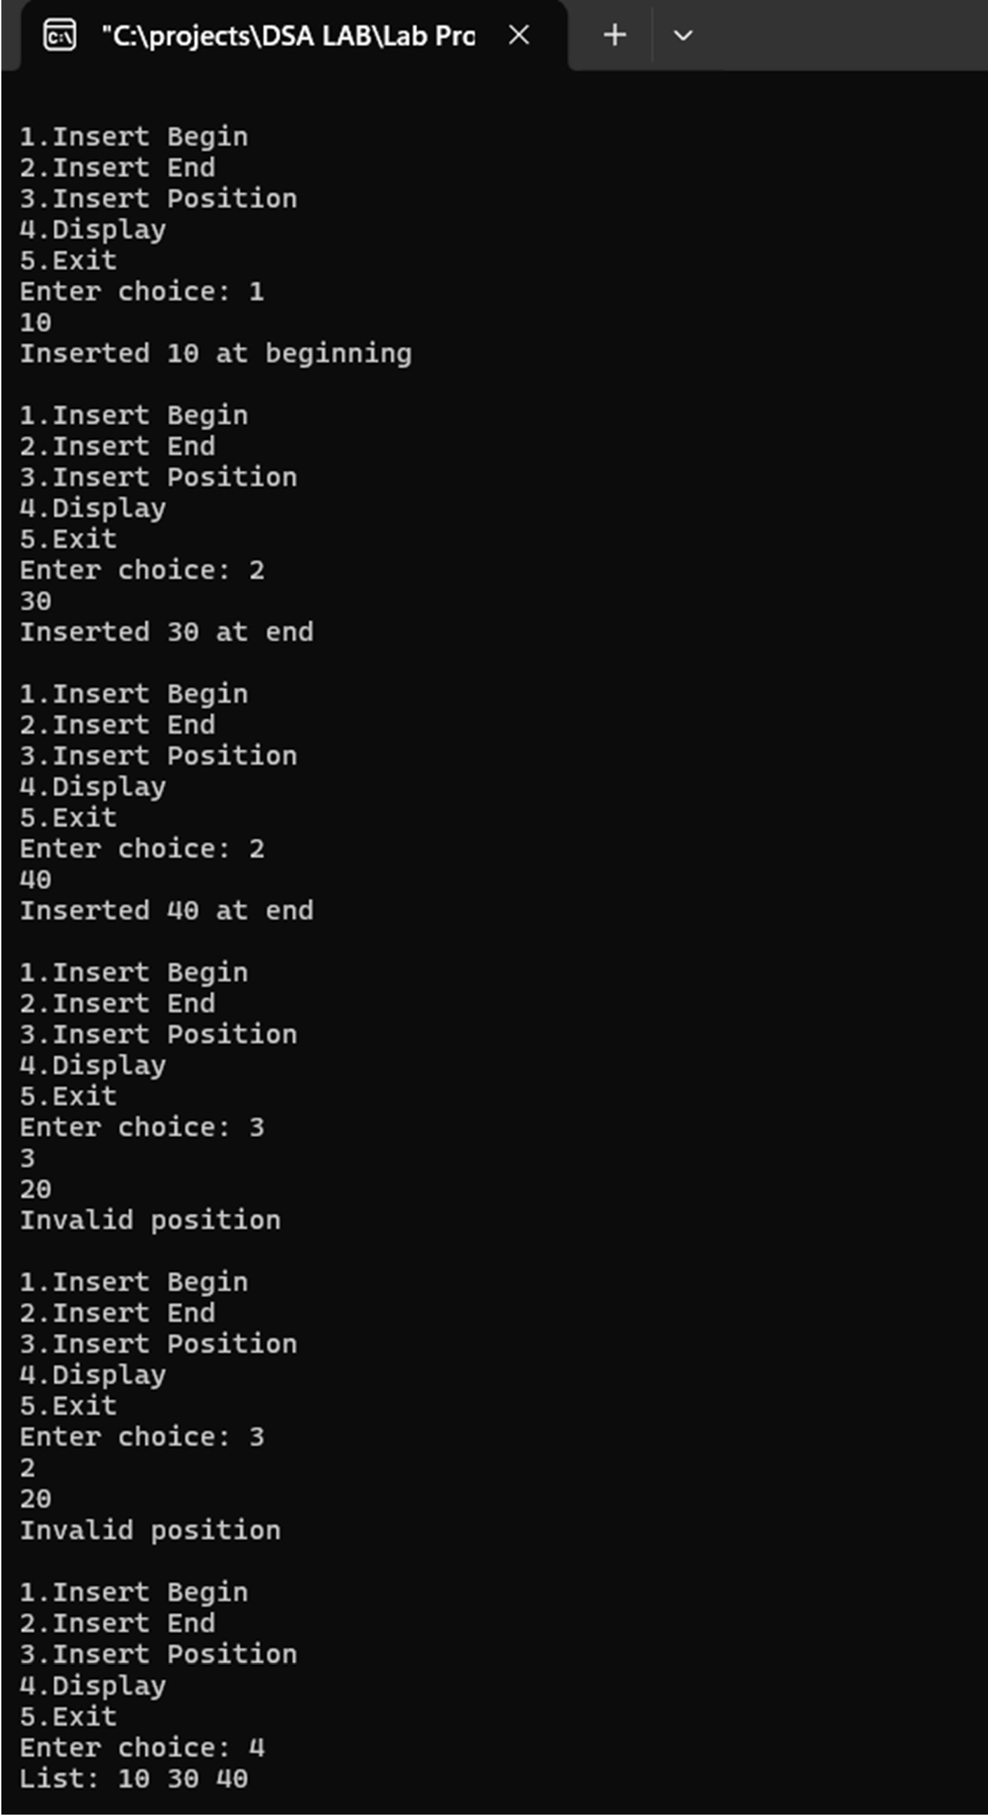

# Program 5:

**WAP to Implement Singly Linked List with following operations a) Create a linked list.**

1. **Deletion of first element, specified element and last element in the list. c) Display the contents of the linked list.**

Code:

#include <stdio.h> #include <stdlib.h>

struct node { int data;

struct node *next;

};

struct node *head = NULL;

struct node* create(int x) {

struct node *n = malloc(sizeof(struct node)); if (!n) {

printf("Memory allocation failed\n"); exit(1);

}

n->data = x;

n->next = NULL; return n;

}

void insert_begin(int x) { struct node *n = create(x); n->next = head; head = n;

printf("Inserted %d at beginning\n", x);

}

void delete_begin() { if (!head) {

printf("List Underflow\n"); return;

}

struct node *t = head;

printf("Deleted %d from beginning\n", t->data); head = head->next;

free(t);

}

void delete_end() {

struct node *t = head, *p = NULL; if (!head) {

printf("List Underflow\n"); return;

}

if (!head->next) {

printf("Deleted %d from end\n", head->data); free(head);

head = NULL; return;

}

while (t->next) { p = t;

t = t->next;

}

p->next = NULL;

printf("Deleted %d from end\n", t->data); free(t);

}

void delete_key(int key) {

struct node *t = head, *p = NULL; if (!head) {

printf("List Underflow\n"); return;

}

if (head->data == key) { delete_begin(); return;

}

while (t && t->data != key) { p = t;

t = t->next;

}

if (!t) {

printf("Element %d not found\n", key); return;

}

p->next = t->next;

printf("Deleted element %d\n", key); free(t);

}

void display() {

struct node *t = head; if (!t) {

printf("List is empty\n");

return;

}

printf("List elements: "); while (t) {

printf("%d ", t->data); t = t->next;

}

printf("\n");

}

int main() { int ch, x; while (1) {

printf("\n1.Insert Begin\n2.Delete Begin\n3.Delete End\n4.Delete Key\n5.Display\n6.Exit\n"); printf("Enter choice: ");

scanf("%d", &ch);

if (ch == 1) { printf("Enter value: "); scanf("%d", &x); insert_begin(x);

}

else if (ch == 2) delete_begin();

else if (ch == 3) delete_end(); else if (ch == 4) {

printf("Enter key: "); scanf("%d", &x); delete_key(x);

}

else if (ch == 5) display();

else if (ch == 6) break;

else

printf("Invalid choice\n");

}

return 0;

}

Output:

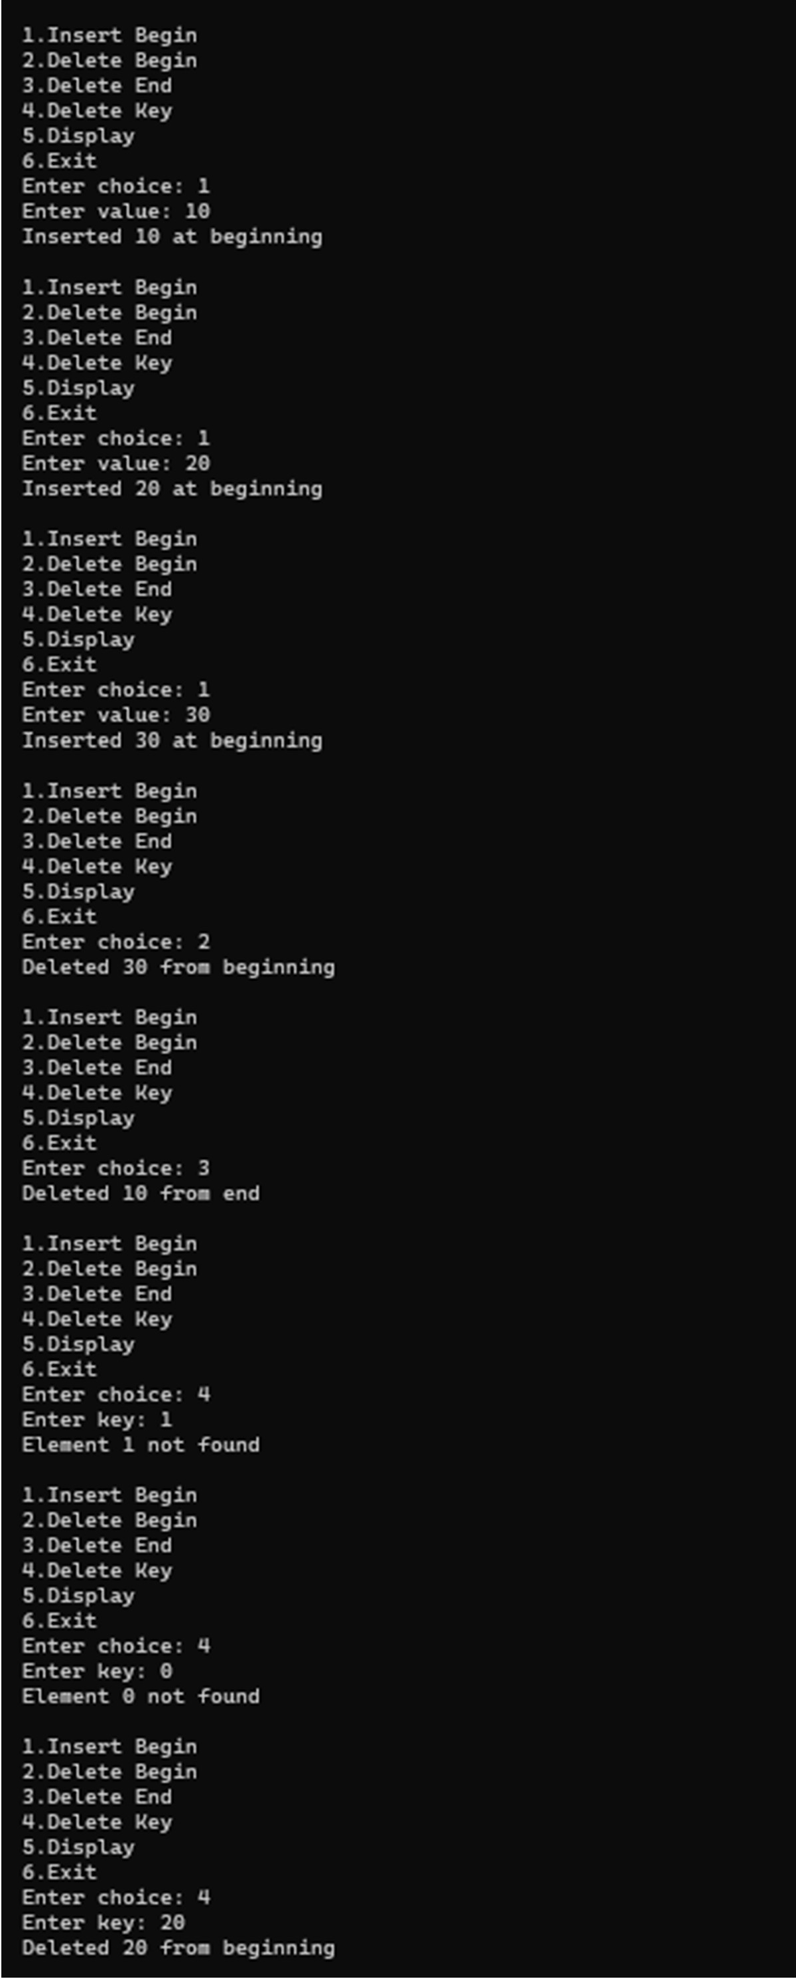

# Program 6a:

1. **WAP to Implement Single Link List with following operations: Sort the linked list, Reverse the linked list, Concatenation of two linked lists.**

Code:

#include <stdio.h> #include <stdlib.h>

struct node { int data;

struct node *next;

};

struct node* create(int x) {

struct node *n = malloc(sizeof(struct node)); if (!n) {

printf("Memory allocation failed\n"); exit(1);

}

n->data = x;

n->next = NULL; return n;

}

struct node* insert(struct node *head, int x) { struct node *n = create(x);

n->next = head; printf("Inserted %d\n", x); return n;

}

void display(struct node *h) {

if (!h) {

printf("List is empty\n"); return;

}

printf("List elements: "); while (h) {

printf("%d ", h->data); h = h->next;

}

printf("\n");

}

struct node* reverse(struct node *h) { struct node *p = NULL, *c = h, *n;

if (!h) {

printf("List is empty. Cannot reverse\n"); return h;

}

while (c) {

n = c->next; c->next = p; p = c;

c = n;

}

printf("List reversed\n"); return p;

}

struct node* sort(struct node *h) { struct node *i, *j;

int t;

if (!h) {

printf("List is empty. Cannot sort\n"); return h;

}

for (i = h; i; i = i->next)

for (j = i->next; j; j = j->next) if (i->data > j->data) {

t = i->data;

i->data = j->data;

j->data = t;

}

printf("List sorted\n"); return h;

}

struct node* concat(struct node *a, struct node *b) { struct node *t = a;

if (!a && !b) {

printf("Both lists are empty\n"); return NULL;

}

if (!a) {

printf("First list empty. Second list returned\n"); return b;

}

while (t->next) t = t->next;

t->next = b;

printf("Lists concatenated\n"); return a;

}

int main() { int m, n, x;

struct node *h1 = NULL, *h2 = NULL;

printf("Enter number of nodes in list 1 and list 2: "); scanf("%d %d", &m, &n);

printf("Enter elements of list 1:\n"); while (m--) {

scanf("%d", &x); h1 = insert(h1, x);

}

printf("Enter elements of list 2:\n"); while (n--) {

scanf("%d", &x); h2 = insert(h2, x);

}

h1 = reverse(h1); display(h1);

h2 = sort(h2); display(h2);

h1 = concat(h1, h2); display(h1);

return 0;

}

Output:

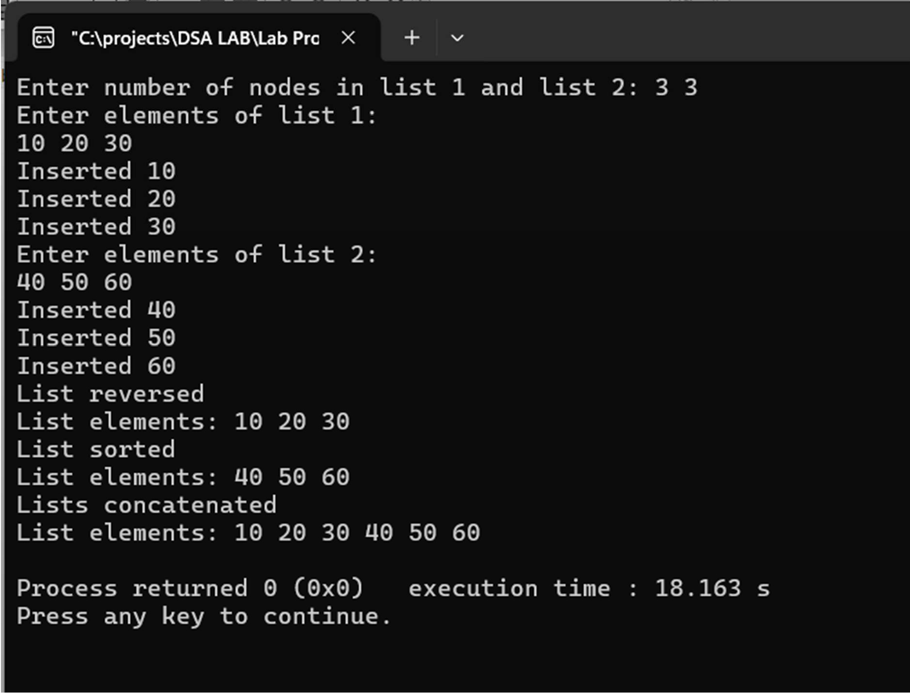

# Program 6b:

1. **WAP to Implement Single Link List to simulate Stack & Queue Operations.**

Code:

#include <stdio.h> #include <stdlib.h>

struct node { int data;

struct node *next;

};

struct node *top = NULL, *front = NULL, *rear = NULL;

void push(int x) {

struct node *n = malloc(sizeof(struct node)); if (!n) {

printf("Memory allocation failed\n"); return;

}

n->data = x;

n->next = top; top = n;

printf("Pushed %d to stack\n", x);

}

void pop() { if (!top) {

printf("Stack Underflow\n"); return;

}

struct node *t = top;

printf("Popped %d from stack\n", t->data); top = top->next;

free(t);

}

void enqueue(int x) {

struct node *n = malloc(sizeof(struct node)); if (!n) {

printf("Memory allocation failed\n"); return;

}

n->data = x;

n->next = NULL; if (!rear)

front = rear = n; else {

rear->next = n; rear = n;

}

printf("Enqueued %d to queue\n", x);

}

void dequeue() { if (!front) {

printf("Queue Underflow\n"); return;

}

struct node *t = front;

printf("Dequeued %d from queue\n", t->data); front = front->next;

if (!front) rear = NULL; free(t);

}

void display_stack() { struct node *t = top; if (!t) {

printf("Stack is empty\n"); return;

}

printf("Stack elements: "); while (t) {

printf("%d ", t->data); t = t->next;

}

printf("\n");

}

void display_queue() { struct node *t = front; if (!t) {

printf("Queue is empty\n"); return;

}

printf("Queue elements: "); while (t) {

printf("%d ", t->data); t = t->next;

}

printf("\n");

}

int main() { int ch, x; while (1) {

printf("\n1.Push\n2.Pop\n3.Display Stack\n4.Enqueue\n5.Dequeue\n6.Display Queue\n7.Exit\n");

printf("Enter choice: "); scanf("%d", &ch);

if (ch == 1) { printf("Enter value: "); scanf("%d", &x); push(x);

}

else if (ch == 2) pop();

else if (ch == 3) display_stack();

else if (ch == 4) { printf("Enter value: "); scanf("%d", &x); enqueue(x);

}

else if (ch == 5) dequeue(); else if (ch == 6)

display_queue(); else if (ch == 7)

break; else

printf("Invalid choice\n");

}

return 0;

}

Output:

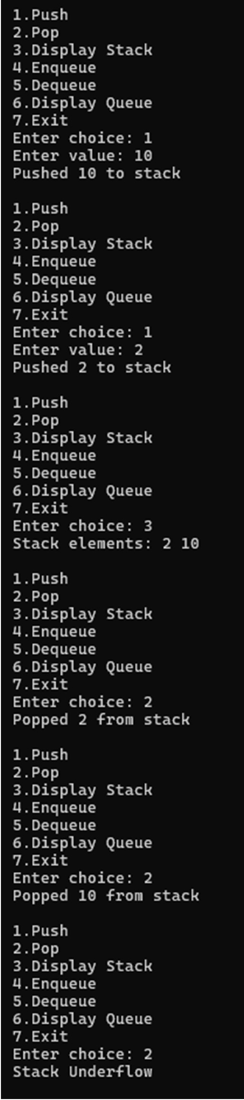

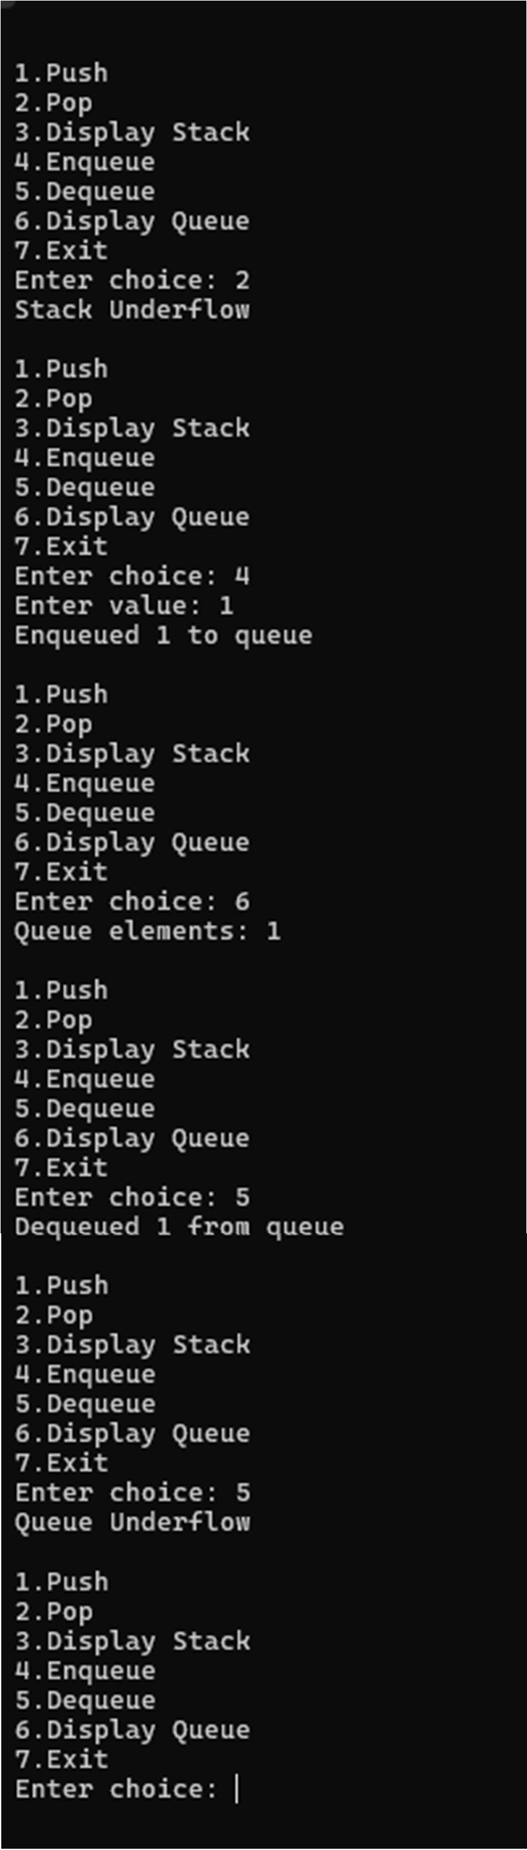

# Program 7:

**WAP to Implement doubly link list with primitive operations a) Create a doubly linked list. b) Insert a new node to the left of the node. c) Delete the node based on a specific value d) Display the contents of the list**

**Code:**

**#include <stdio.h> #include <stdlib.h>**

**struct node { int data;**

**struct node *prev, *next;**

**};**

**struct node *head = NULL;**

**struct node* create(int x) {**

**struct node *n = malloc(sizeof(struct node)); if (!n) {**

**printf("Memory allocation failed\n"); exit(1);**

**}**

**n->data = x;**

**n->prev = n->next = NULL; return n;**

**}**

**void insert_end(int x) {**

**struct node *n = create(x), *t = head; if (!head) {**

**head = n;**

**printf("Inserted %d as first node\n", x); return;**

**}**

**while (t->next) t = t->next;**

**t->next = n; n->prev = t;**

**printf("Inserted %d at end\n", x);**

**}**

**void insert_left(int x, int key) { struct node *t = head;**

**while (t && t->data != key) t = t->next;**

**if (!t) {**

**printf("Key %d not found. Insertion failed\n", key); return;**

**}**

**struct node *n = create(x); n->next = t;**

**n->prev = t->prev;**

**if (t->prev)**

**t->prev->next = n; else**

**head = n;**

**t->prev = n;**

**printf("Inserted %d to the left of %d\n", x, key);**

**}**

**void delete_key(int key) { struct node *t = head;**

**if (!head) {**

**printf("List Underflow\n"); return;**

**}**

**while (t && t->data != key) t = t->next;**

**if (!t) {**

**printf("Key %d not found\n", key); return;**

**}**

**if (t->prev)**

**t->prev->next = t->next; else**

**head = t->next;**

**if (t->next)**

**t->next->prev = t->prev;**

**printf("Deleted node with value %d\n", key); free(t);**

**}**

**void display() {**

**struct node *t = head; if (!t) {**

**printf("List is empty\n"); return;**

**}**

**printf("Doubly Linked List: "); while (t) {**

**printf("%d ", t->data); t = t->next;**

**}**

**printf("\n");**

**}**

**int main() { int ch, x, k; while (1) {**

**printf("\n1.Insert End\n2.Insert Left\n3.Delete Key\n4.Display\n5.Exit\n"); printf("Enter choice: ");**

**scanf("%d", &ch);**

**if (ch == 1) { printf("Enter value: "); scanf("%d", &x); insert_end(x);**

**}**

**else if (ch == 2) {**

**printf("Enter new value and key: "); scanf("%d %d", &x, &k); insert_left(x, k);**

**}**

**else if (ch == 3) {**

**printf("Enter key to delete: "); scanf("%d", &k); delete_key(k);**

**}**

**else if (ch == 4) display();**

**else if (ch == 5) break;**

**else**

**printf("Invalid choice\n");**

**}**

**return 0;**

**}**

**Output:**

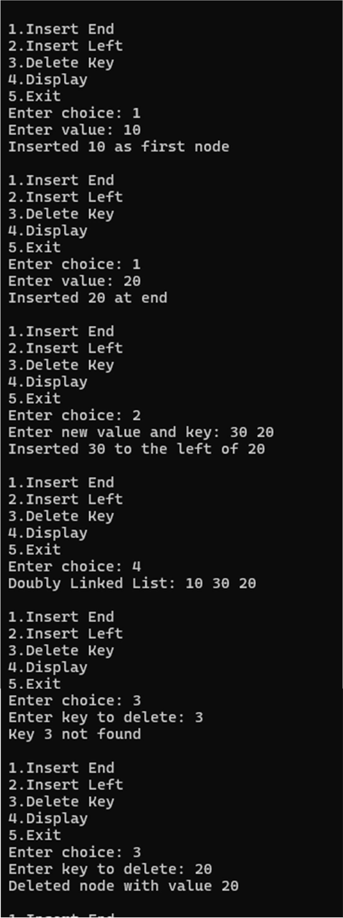

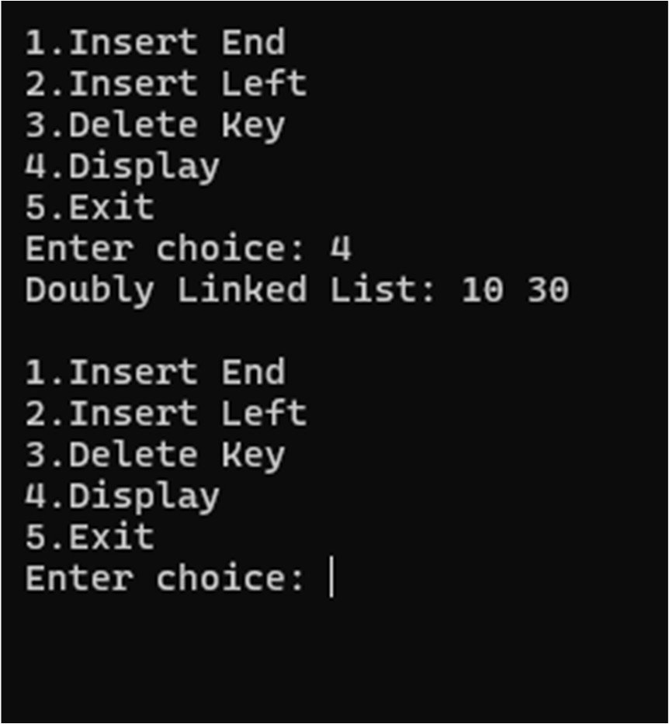

# Program 8:

**Write a program a) To construct a binary Search tree. b) To traverse the tree using all the methods i.e., in-order, preorder and post order c) To display the elements in the tree.**

Code:

#include <stdio.h> #include <stdlib.h>

struct node { int data;

struct node *l, *r;

};

struct node* create(int x) {

struct node *n = malloc(sizeof(struct node)); if (!n) {

printf("Memory allocation failed\n"); exit(1);

}

n->data = x;

n->l = n->r = NULL;

return n;

}

struct node* insert(struct node *r, int x) { if (!r) {

printf("Inserted %d\n", x); return create(x);

}

if (x < r->data) r->l = insert(r->l, x);

else if (x > r->data)

r->r = insert(r->r, x); else

printf("Duplicate value %d not inserted\n", x); return r;

}

void inorder(struct node *r) { if (!r) return;

inorder(r->l); printf("%d ", r->data); inorder(r->r);

}

void preorder(struct node *r) { if (!r) return;

printf("%d ", r->data); preorder(r->l); preorder(r->r);

}

void postorder(struct node *r) { if (!r) return;

postorder(r->l); postorder(r->r); printf("%d ", r->data);

}

int main() { int ch, x;

struct node *root = NULL;

while (1) { printf("\n1.Insert\n2.Inorder\n3.Preorder\n4.Postorder\n5.Exit\n"); printf("Enter choice: ");

scanf("%d", &ch);

if (ch == 1) { printf("Enter value: "); scanf("%d", &x);

root = insert(root, x);

}

else if (ch == 2) {

if (!root) printf("Tree is empty\n"); else {

printf("Inorder traversal: "); inorder(root);

printf("\n");

}

}

else if (ch == 3) {

if (!root) printf("Tree is empty\n"); else {

printf("Preorder traversal: "); preorder(root);

printf("\n");

}

}

else if (ch == 4) {

if (!root) printf("Tree is empty\n"); else {

printf("Postorder traversal: ");

postorder(root); printf("\n");

}

}

else if (ch == 5) break;

else

printf("Invalid choice\n");

}

return 0;

}

Output:

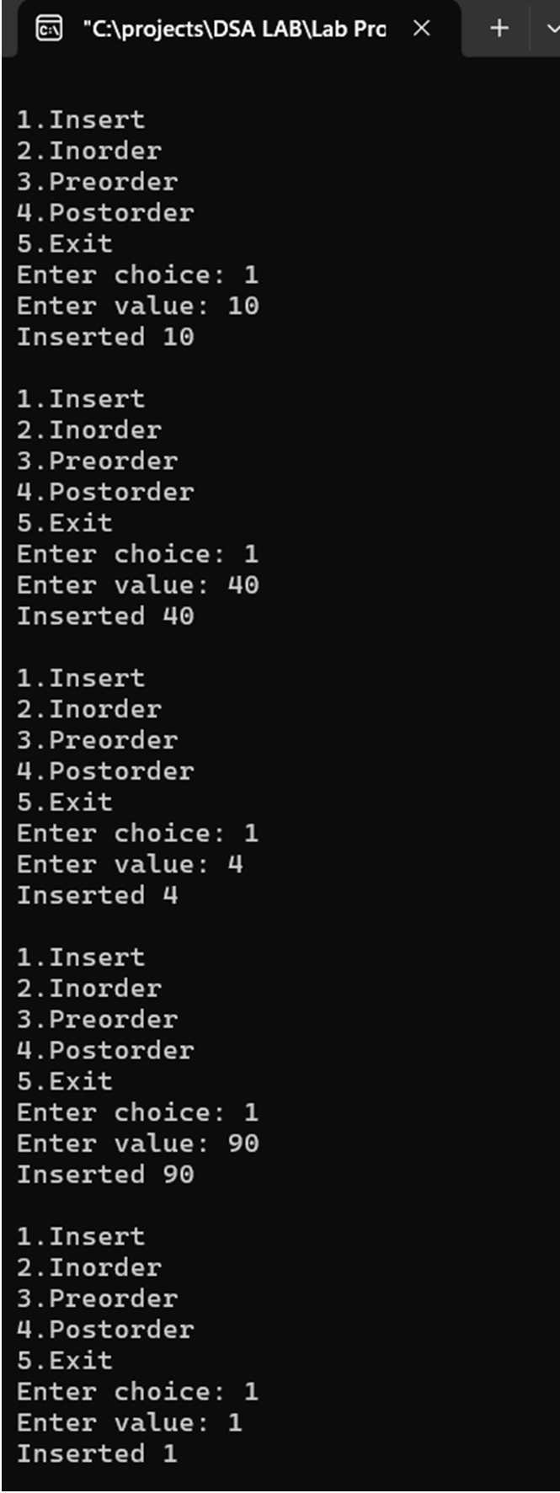

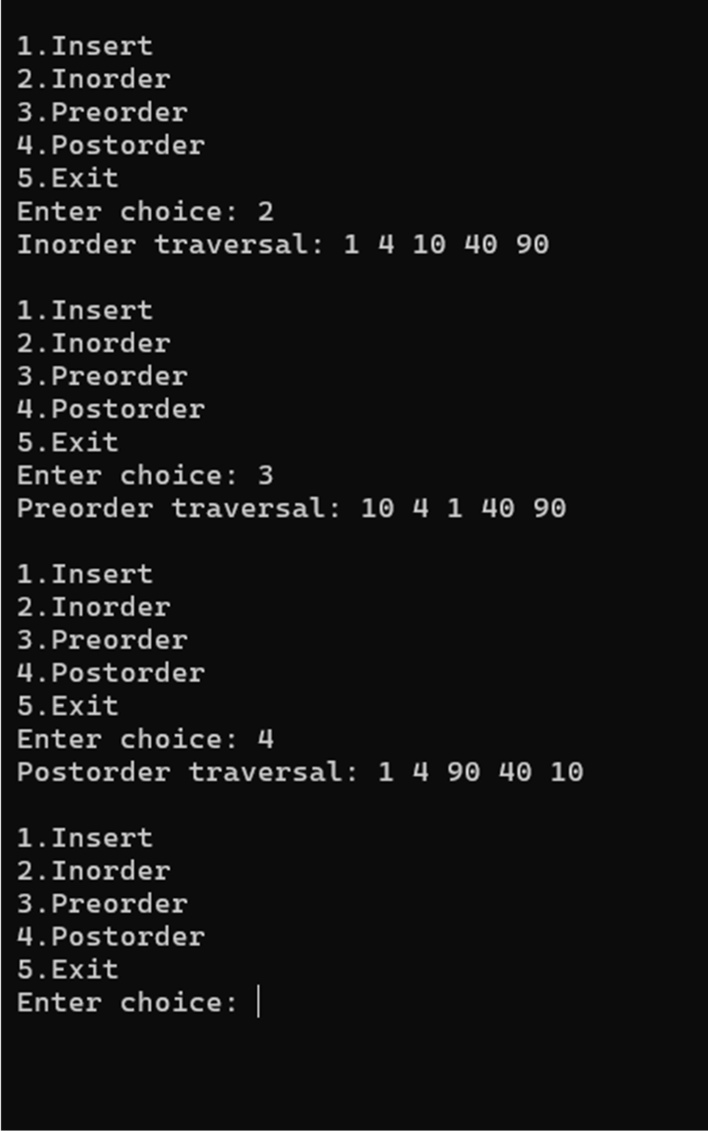

# Program 9a:

1. **Write a program to traverse a graph using BFS method.**

Output:

#include <stdio.h> #define MAX 20

int queue[MAX], front = -1, rear = -1; int visited[MAX];

void enqueue(int vertex) { if (rear == MAX - 1) {

printf("Queue Overflow!\n"); return;

}

if (front == -1) front = 0; queue[++rear] = vertex;

}

int dequeue() {

if (front == -1 || front > rear) { return -1;

}

return queue[front++];

}

int isEmpty() {

return (front == -1 || front > rear);

}

void BFS(int adj[MAX][MAX], int n, int start) { for (int i = 0; i < n; i++) visited[i] = 0;

enqueue(start); visited[start] = 1;

printf("BFS Traversal starting from vertex %d: ", start);

while (!isEmpty()) { int v = dequeue(); printf("%d ", v);

for (int i = 0; i < n; i++) {

if (adj[v][i] == 1 && !visited[i]) { enqueue(i);

visited[i] = 1;

}

}

}

printf("\n");

}

int main() {

int n, adj[MAX][MAX], start; printf("Enter number of vertices: "); scanf("%d", &n);

printf("Enter adjacency matrix (%d x %d):\n", n, n); for (int i = 0; i < n; i++) {

for (int j = 0; j < n; j++) { scanf("%d", &adj[i][j]);

}

}

printf("Enter starting vertex (0 to %d): ", n - 1); scanf("%d", &start);

BFS(adj, n, start); return 0;

}

Output:

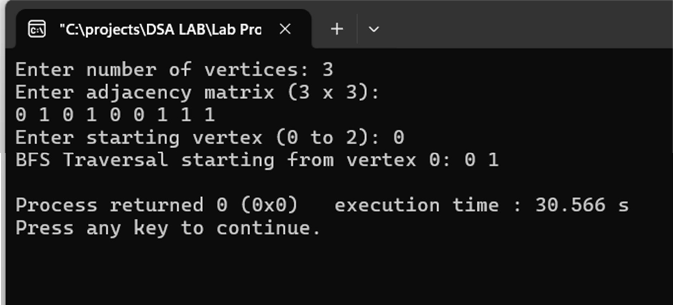

# Program 9b:

1. **Write a program to check whether given graph is connected or not using DFS method.**

Code:

#include <stdio.h> #define MAX 20 int visited[MAX];

void DFS(int adj[MAX][MAX], int n, int start) { visited[start] = 1;

for (int i = 0; i < n; i++) {

if (adj[start][i] == 1 && !visited[i]) { DFS(adj, n, i);

}

}

}

int main() {

int n, adj[MAX][MAX], start = 0; printf("Enter number of vertices: "); scanf("%d", &n);

printf("Enter adjacency matrix (%d x %d):\n", n, n); for (int i = 0; i < n; i++) {

for (int j = 0; j < n; j++) { scanf("%d", &adj[i][j]);

}

}

for (int i = 0; i < n; i++) visited[i] = 0; DFS(adj, n, start);

int connected = 1;

for (int i = 0; i < n; i++) {

if (!visited[i]) { connected = 0; break;

}

}

if (connected)

printf("The graph is connected.\n"); else

printf("The graph is NOT connected.\n"); return 0;

}

Output:

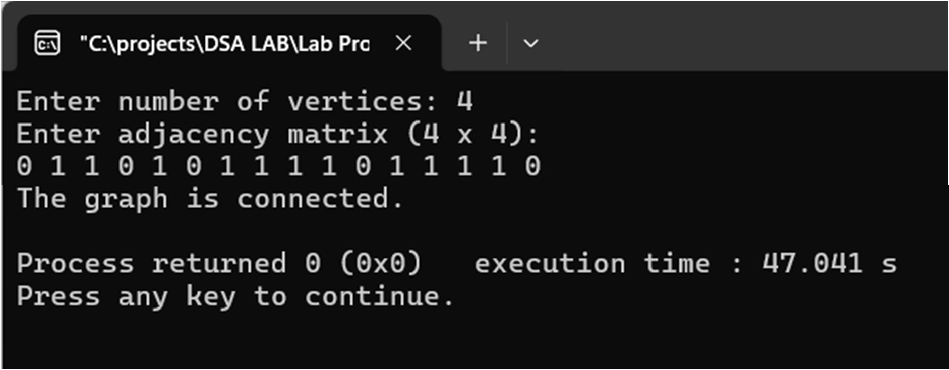

# Program 10:

**Given a File of N employee records with a set K of Keys(4 digit) which uniquely determine the records in file F. Assume that file F is maintained in memory by a Hash Table (HT) of m memory locations with L as the set of memory addresses (2-digit) of locations in HT. Let the keys in K and addresses in L are integers. Design and develop a Program in C that uses Hash function H: K -> L as H(K)=K mod m (remainder method), and implement hashing technique to map a given key K to the address space L. Resolve the collision (if any) using linear probing.**

Code: #include<stdio.h>

#include<stdlib.h> int key[20], n, m; int *ht, index;

int count = 0;

void insert(int key)

{

index = key % m; while(ht[index] != -1)

{

index = (index+1)%m;

}

ht[index] = key; count++;

}

void display()

{

int i;

if(count == 0)

{

printf("\nHash Table is empty"); return;

}

printf("\nHash Table contents are:\n "); for(i=0; i<m; i++)

printf("\n T[%d] --> %d ", i, ht[i]);

}

void main()

{

int i;

printf("\nEnter the number of employee records (N) : "); scanf("%d", &n);

printf("\nEnter the two digit memory locations (m) for hash table: ");

scanf("%d", &m);

ht = (int *)malloc(m*sizeof(int)); for(i=0; i<m; i++)

ht[i] = -1;

printf("\nEnter the four digit key values (K) for N Employee Records:\n “);

for(i=0; i<n; i++) scanf("%d", &key[i]); for(i=0; i<n; i++)

{

if(count == m)

{

printf("\nHash table is full. Cannot insert the record %d key", i+1);

break;

}

insert(key[i]);

}

display();

}

Output:

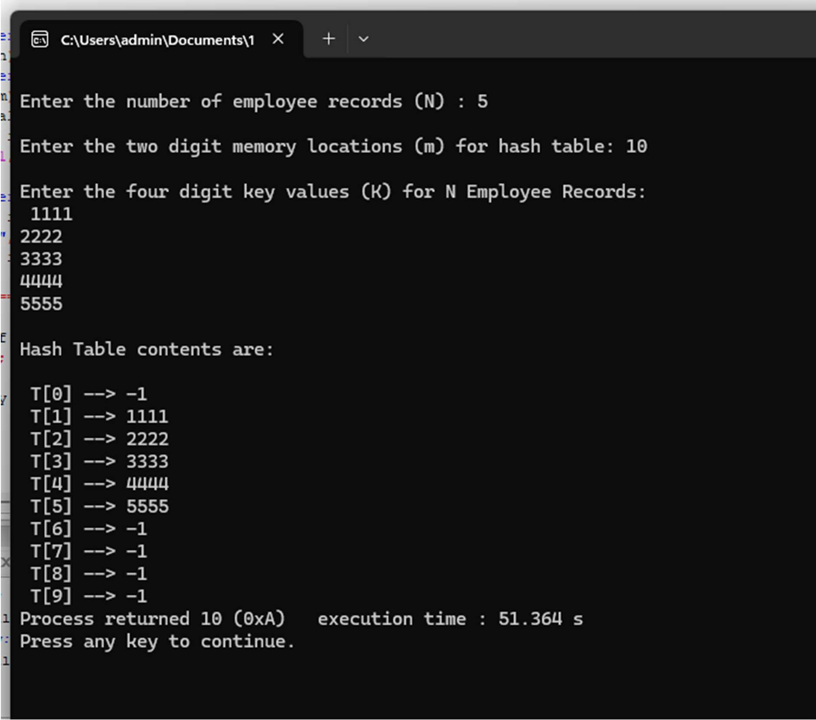

**Leetcode Problem:**

* 1. **203 – Remove Linked List Elements Given the head of a linked list and an integer val, remove all the nodes of the linked list that have Node.val**

**== val, and return the new head. Example 1: Input: head = [1,2,6,3,4,5,6], val = 6 Output: [1,2,3,4,5] Example 2: Input: head = [], val = 1 Output: [] Example 3: Input: head = [7,7,7,7], val = 7 Output: []**

**Code:**

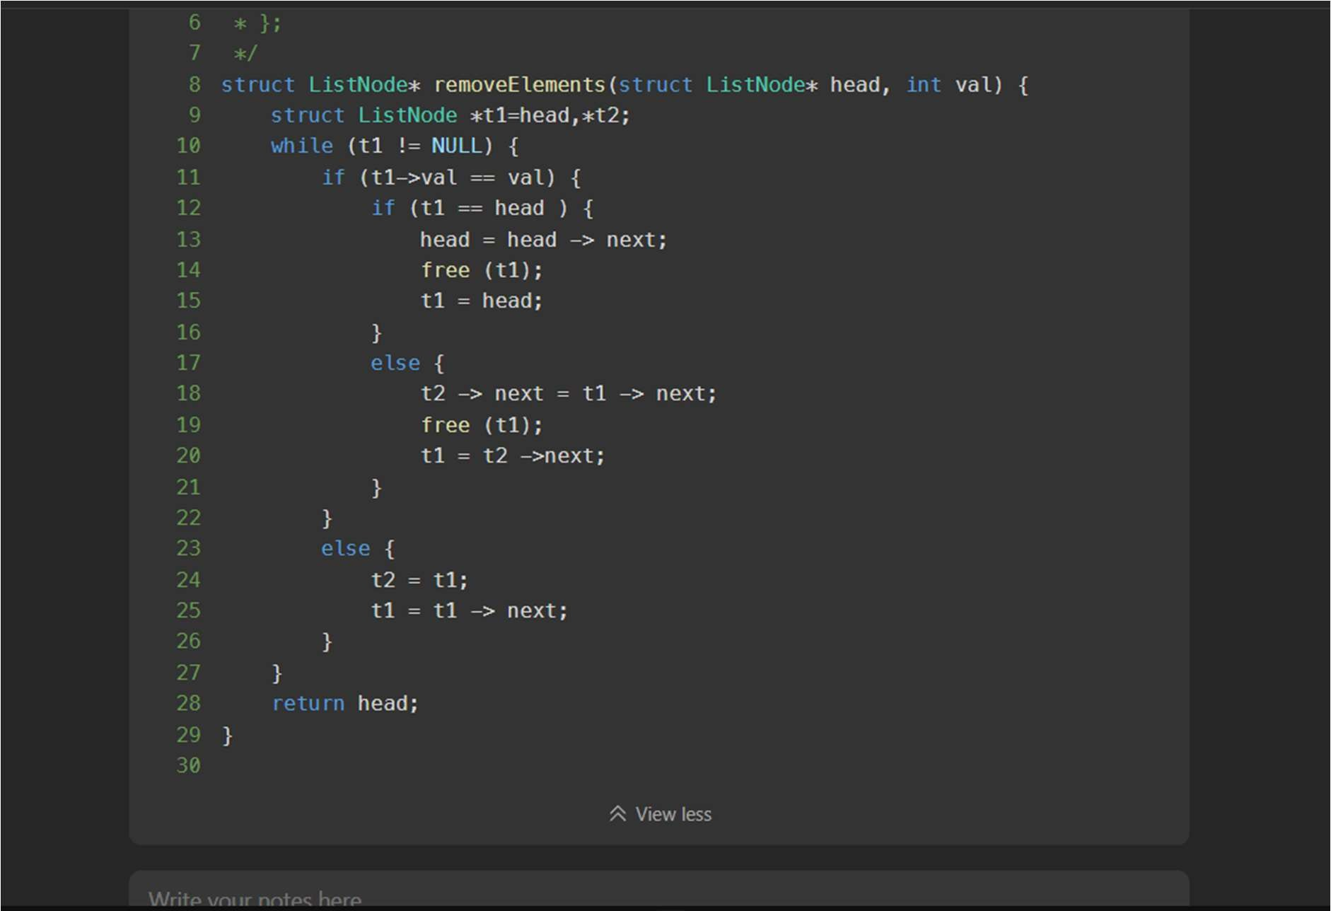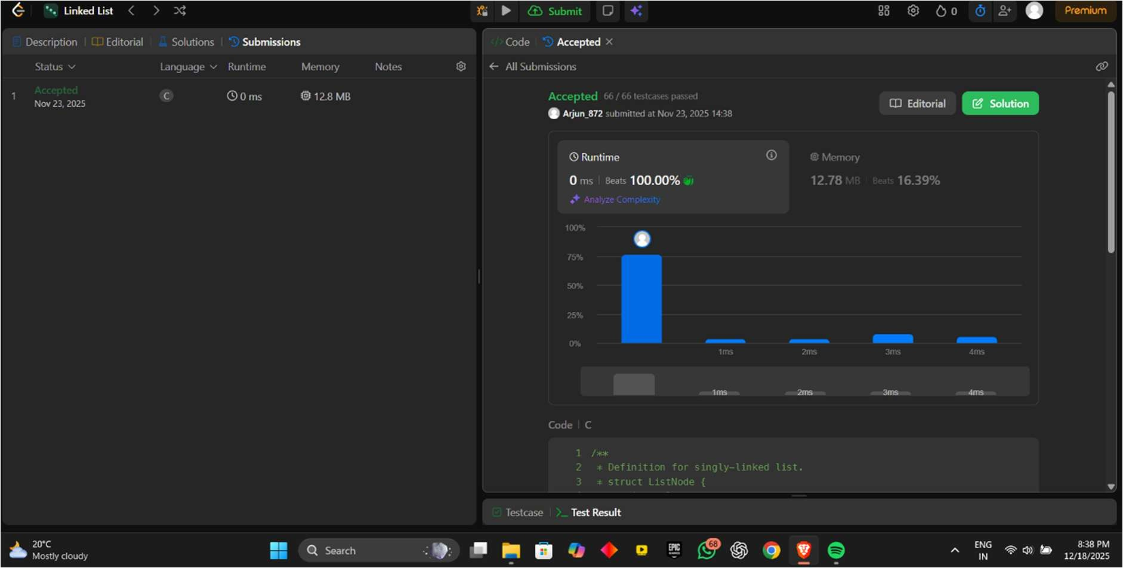

* 1. **148 – Sort List Given the head of a linked list, return the list after sorting it in ascending order. Example 1: Input: head = [4,2,1,3] Output: [1,2,3,4] Example 2: Input: head = [-1,5,3,4,0] Output: [-1,0,3,4,5] Example 3: Input: head = [] Output: []**

**Code:**

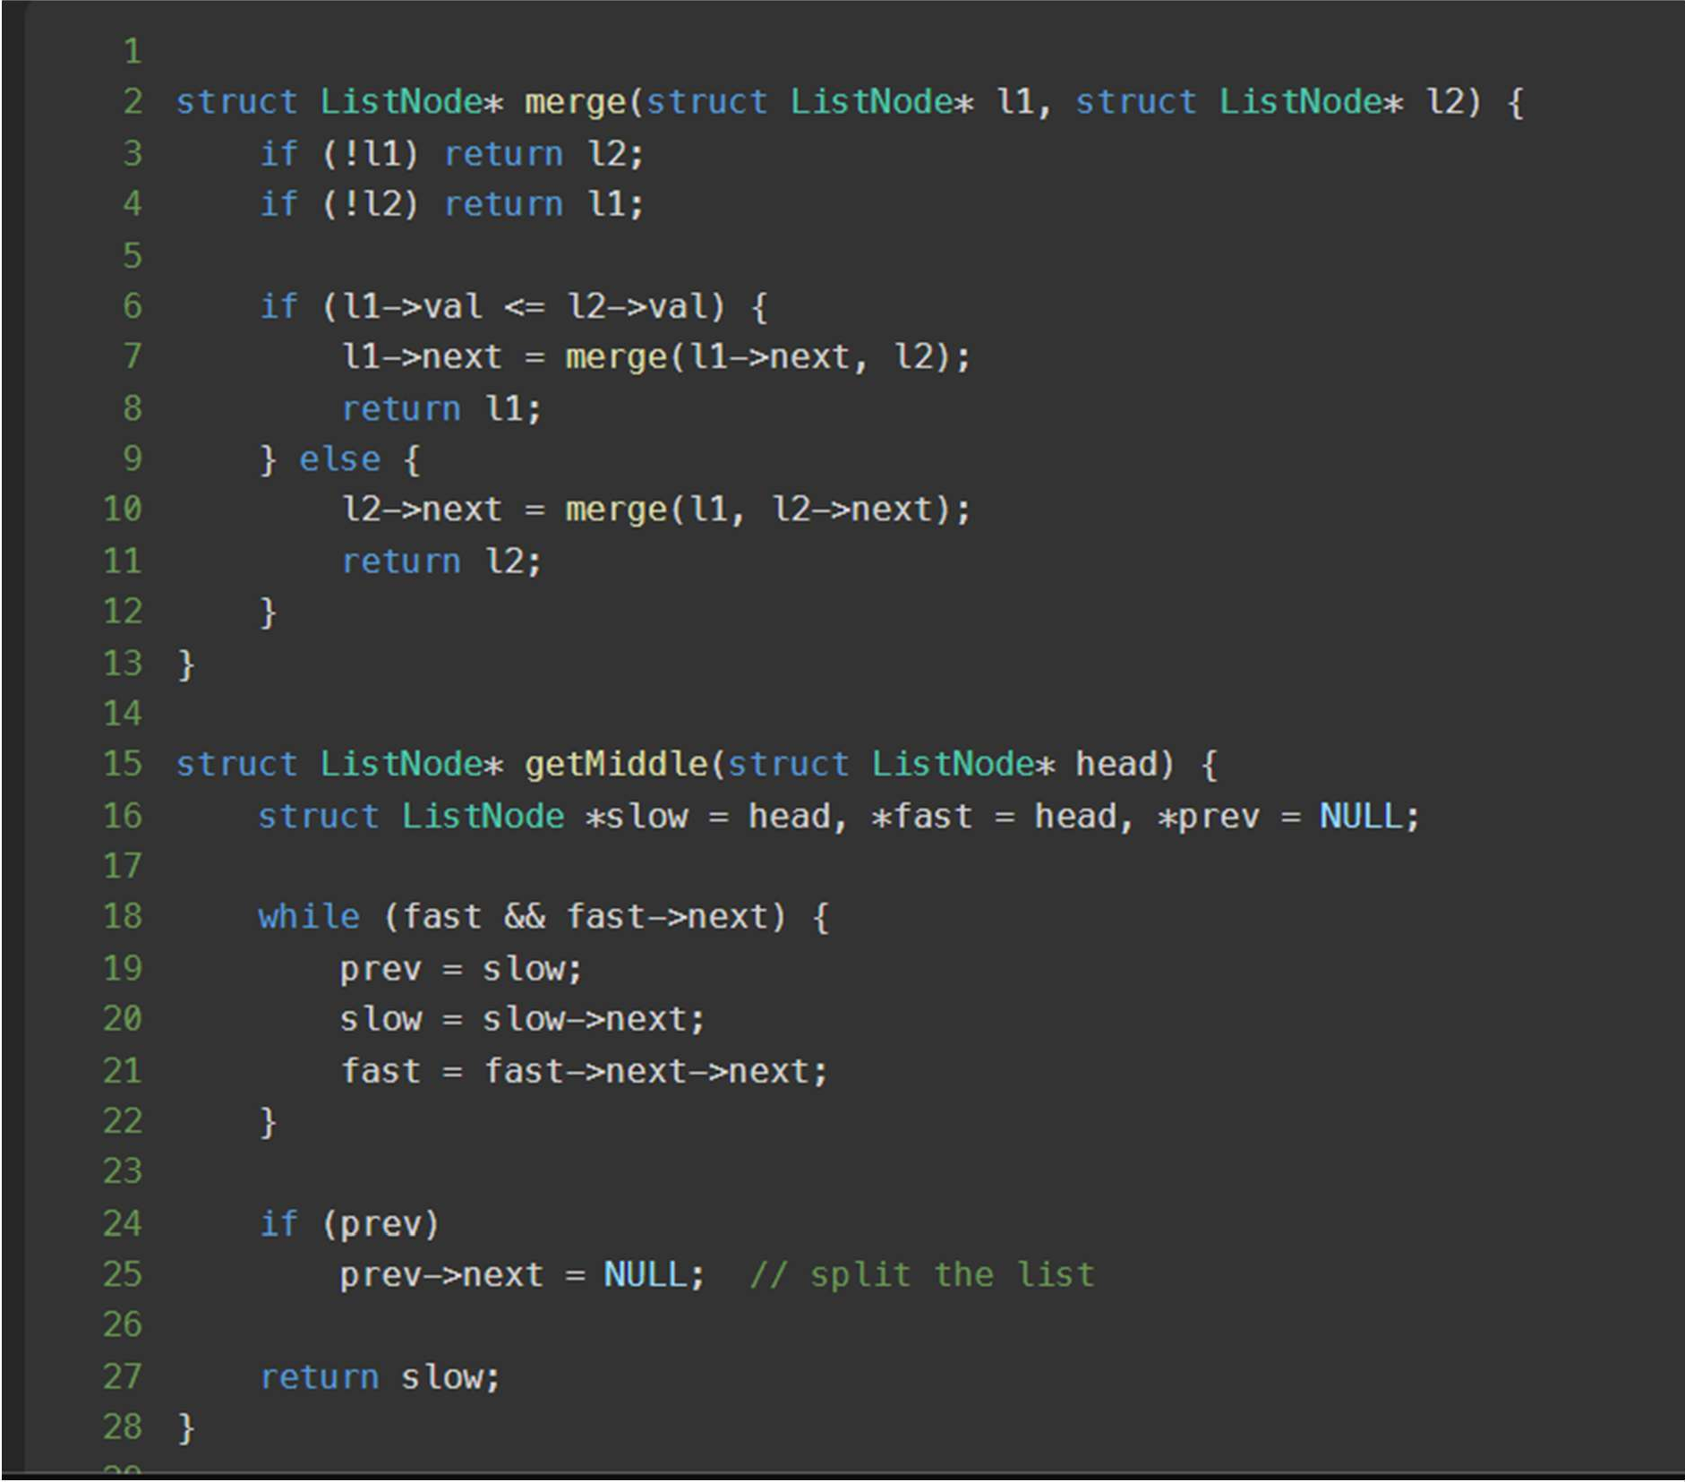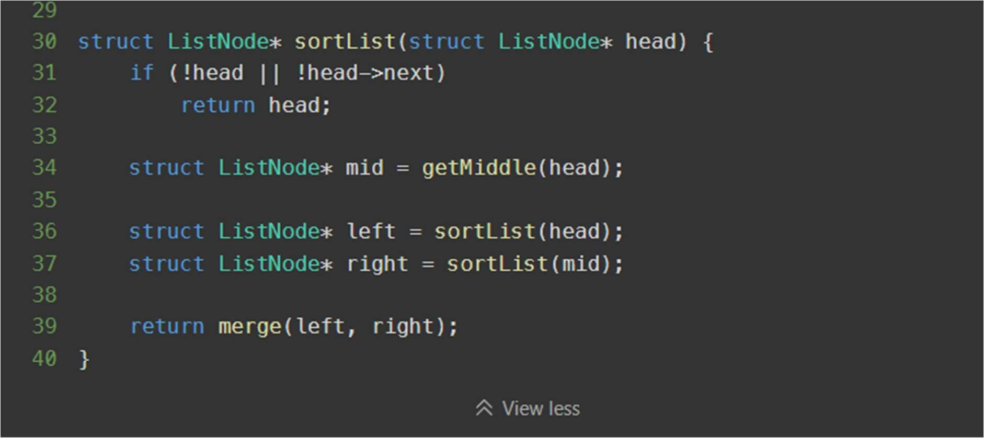

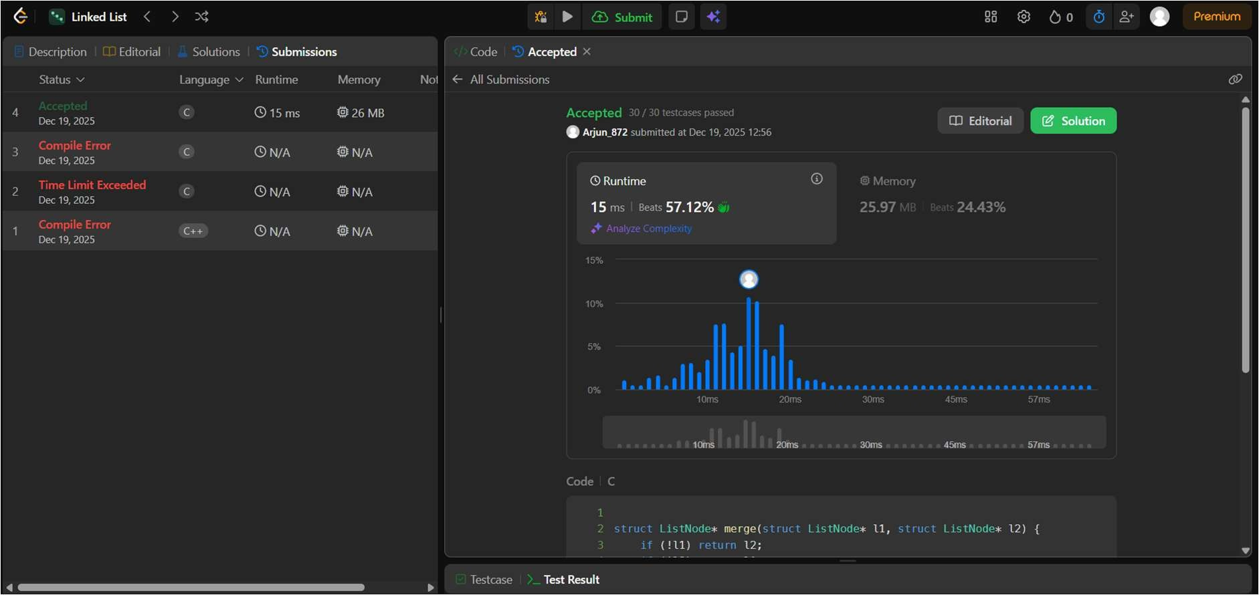

* 1. **Given the head of a singly linked list, reverse the list, and return the reversed list. Example 1: Input: head = [1,2,3,4,5] Output: [5,4,3,2,1] Example 2: Input: head = [1,2] Output: [2,1] Example 3: Input: head = [] Output: []**

**Code:**

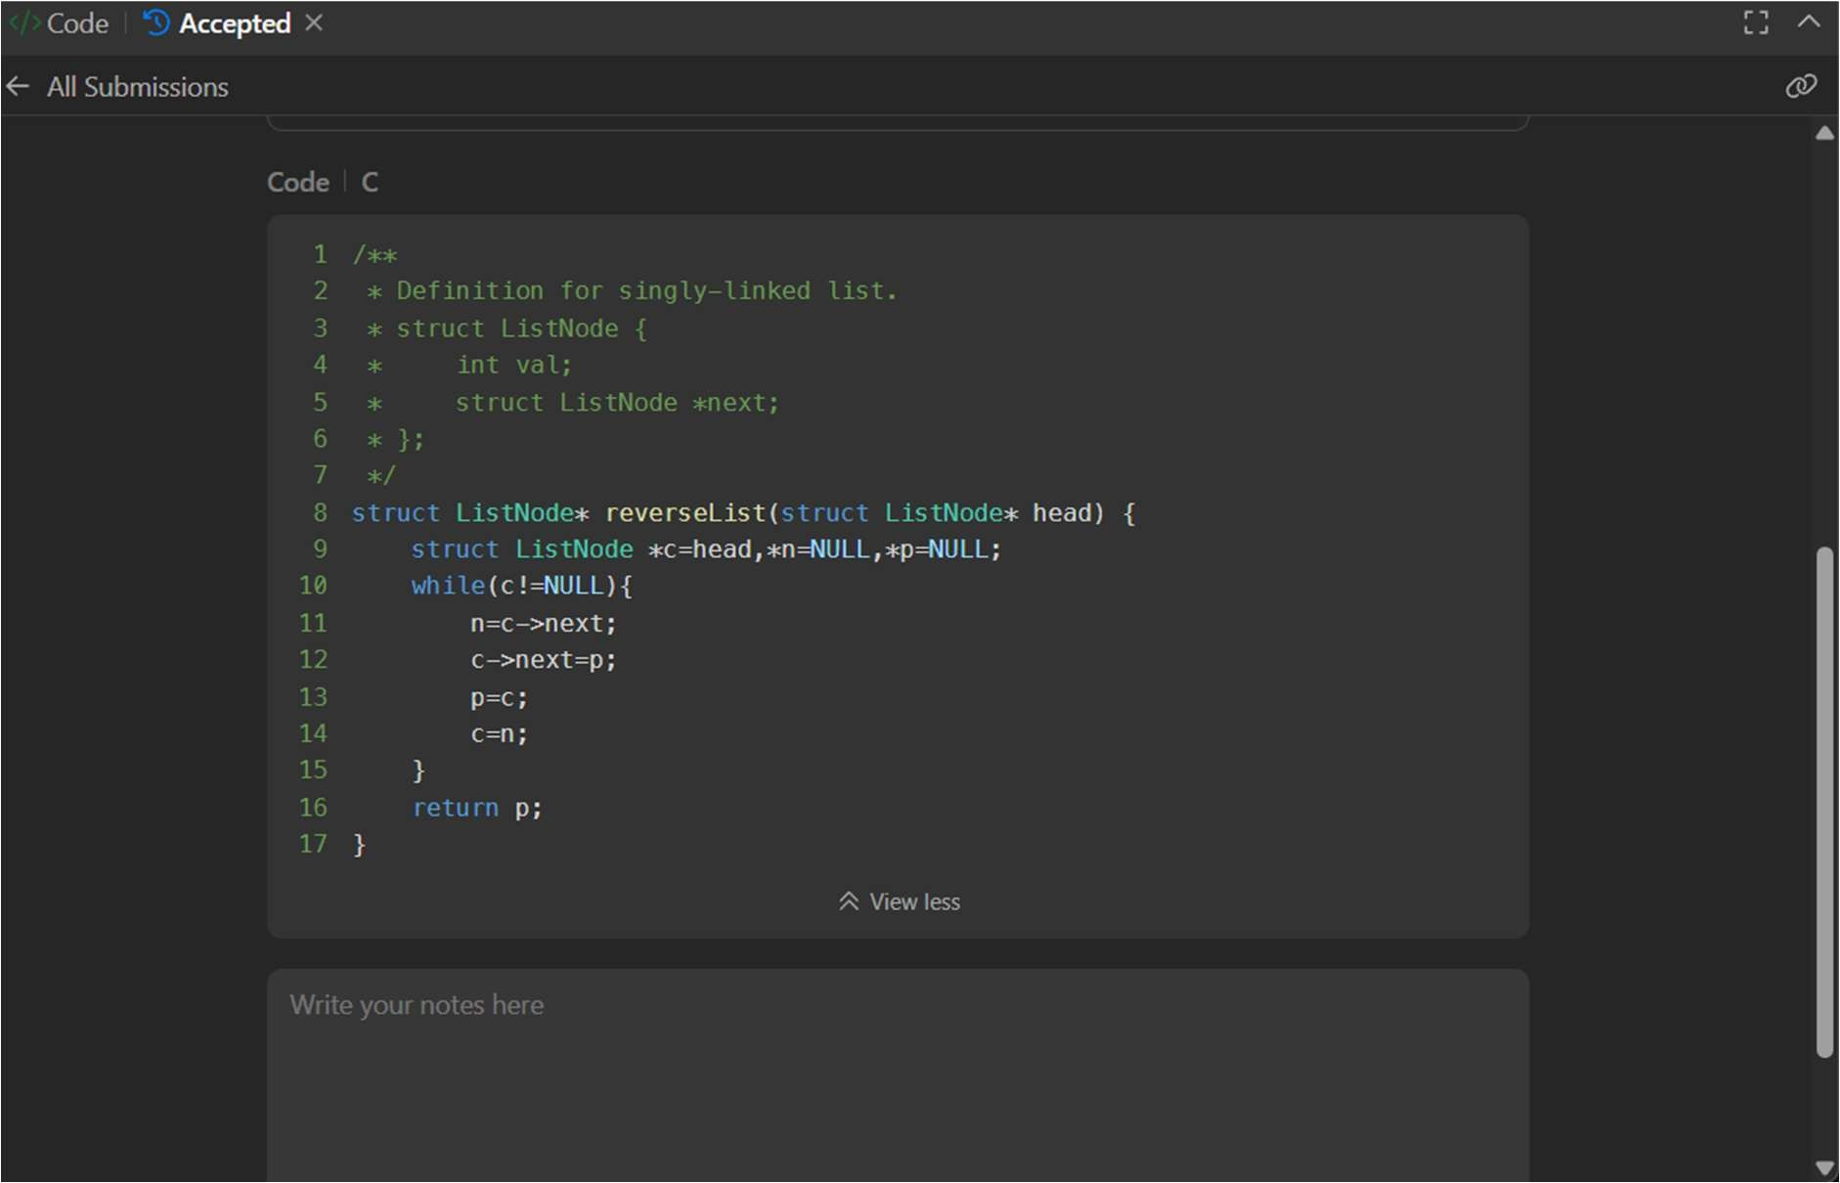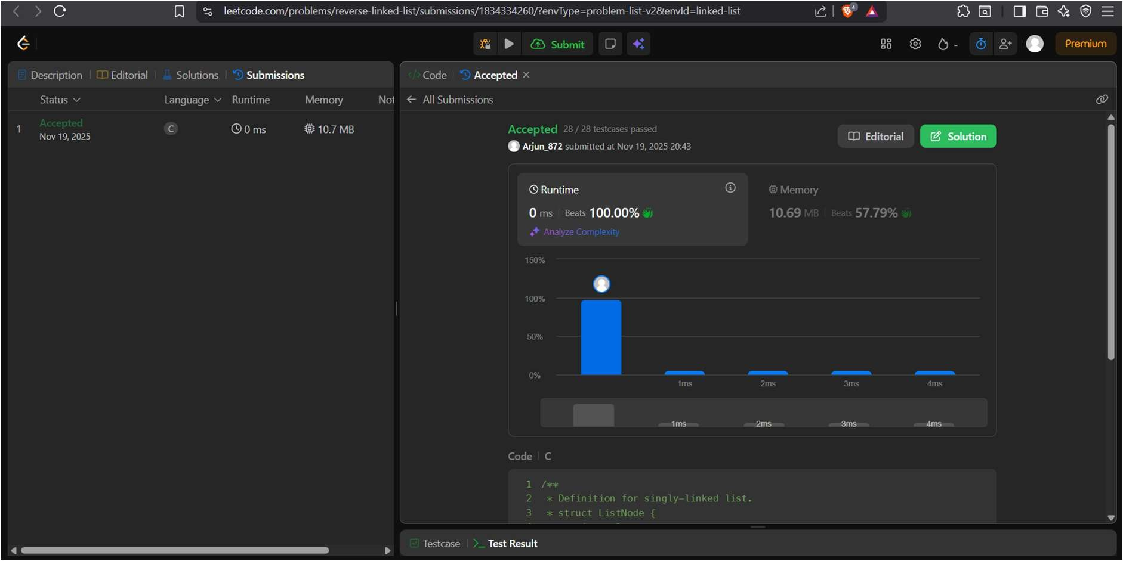

* 1. **21 – Merge Two Sorted Lists You are given the heads of two sorted linked lists list1 and list2. Merge the two lists into one sorted list. The list should be made by splicing together the nodes of the first two lists. Return the head of the merged linked list. Example 1: Input: list1 = [1,2,4], list2 = [1,3,4] Output: [1,1,2,3,4,4] Example 2: Input: list1 = [], list2**

**= [] Output: [] Example 3: Input: list1 = [], list2 = [0] Output: [0]**

**Code:**

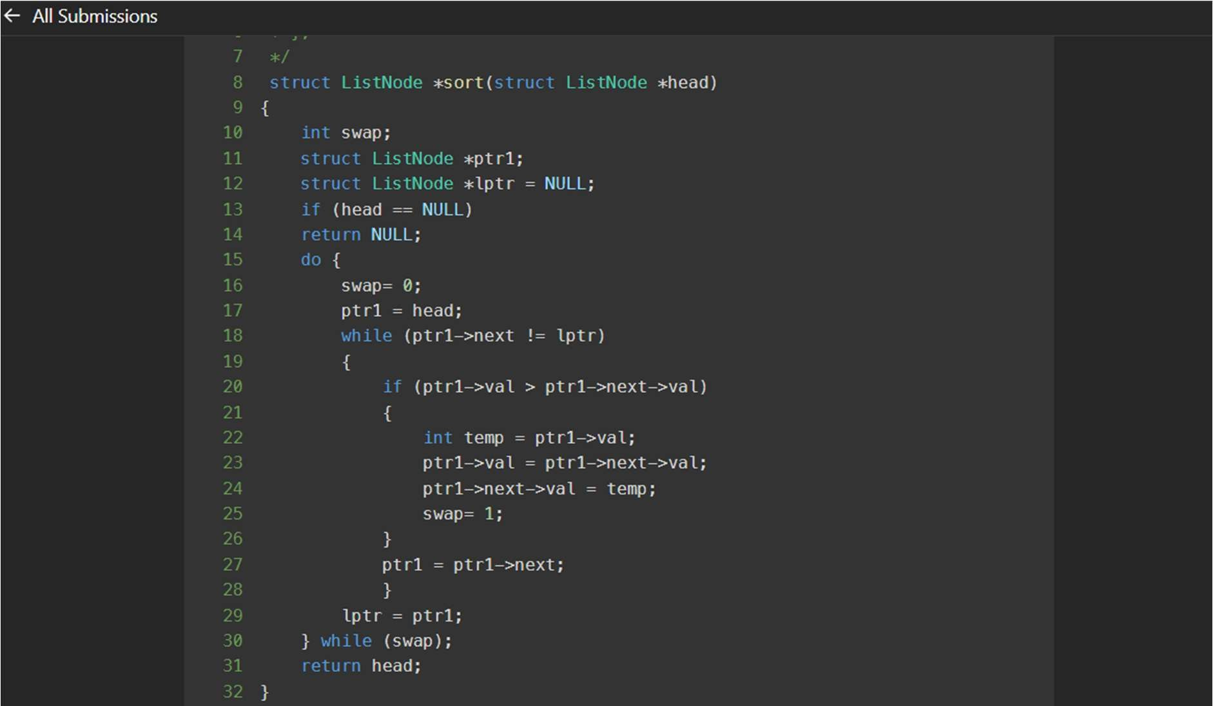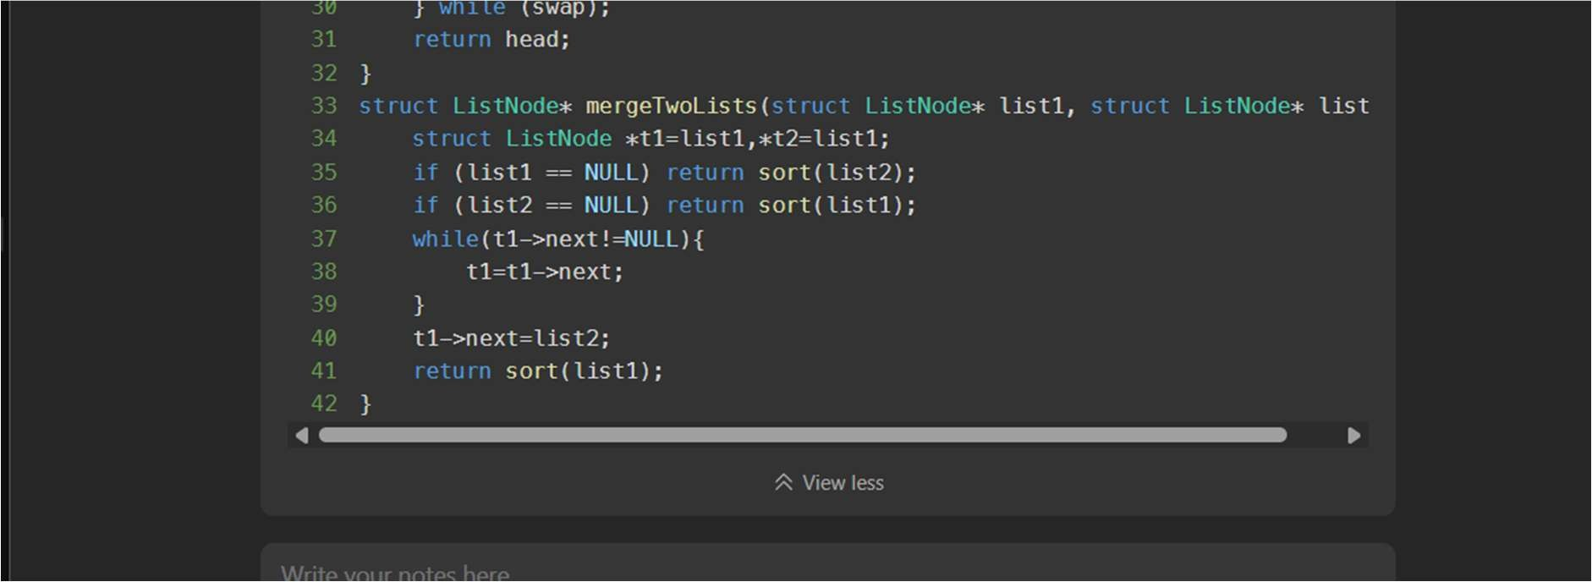

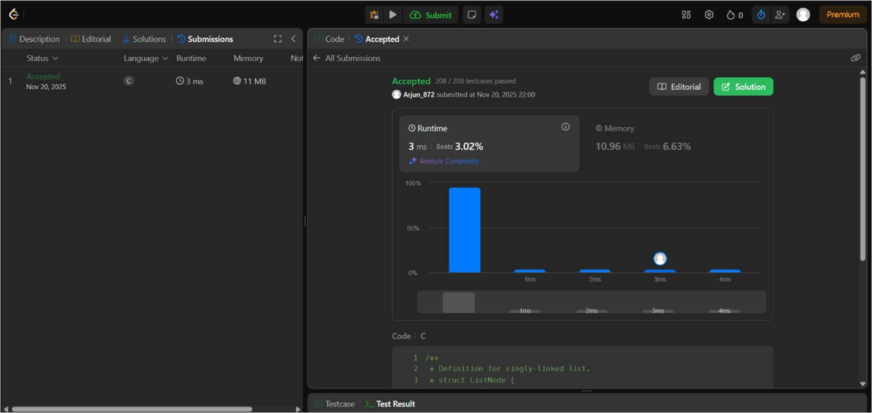

* 1. **141 – Linked List Cycle Given head, the head of a linked list, determine if the linked list has a cycle in it. There is a cycle in a linked list if there is some node in the list that can be reached again by continuously following the next pointer. Internally, pos is used to denote the index of the node that the tail’s next pointer is connected to. Note that pos is not passed as a parameter. Return true if there is a cycle in the linked list. Otherwise, return false. Example 1: Input: head = [3,2,0,-4], pos = 1 Output: true Explanation: There is a cycle in the linked list, where the tail connects to the 1st node (0- indexed). Example 2: Input: head = [1,2], pos = 0 Output: true Explanation: There is a cycle in the linked list, where the tail connects to the 0th node. Example 3: Input: head = [1], pos = -1 65| Page Output: false Explanation: There is no cycle in the linked list.**

**Code:**

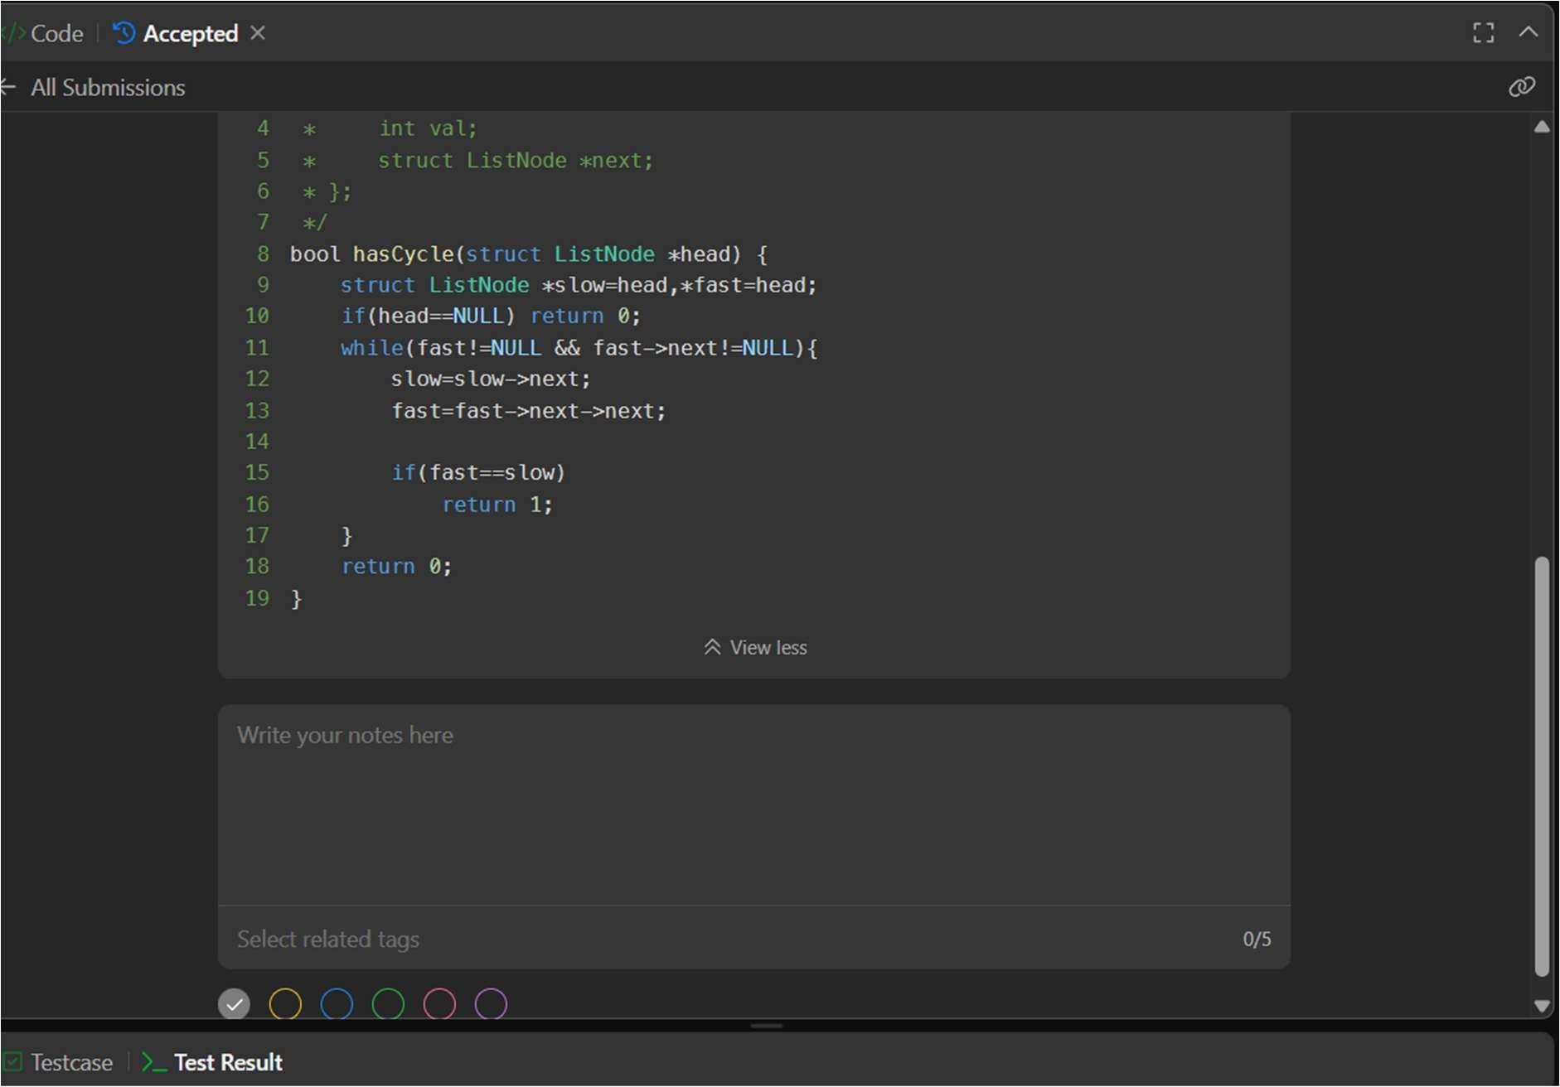

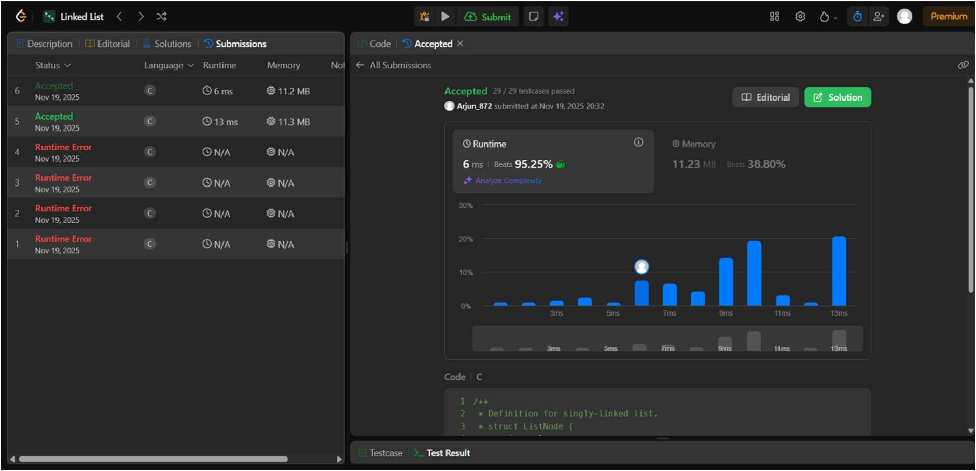

* 1. **142 – Linked List Cycle II Given the head of a linked list, return the node where the cycle begins. If there is no cycle, return null. There is a cycle in a linked list if there is some node in the list that can be reached again by continuously following the next pointer. Internally, pos is used to denote the index (0-indexed) of the node that the tail’s next pointer is connected to. If pos is -1, then there is no cycle. Note that pos is not passed as a parameter. Do not modify the linked list. Example 1: Input: head = [3,2,0,-4], pos = 1 Output: tail connects to node index 1 Explanation: There is a cycle in the linked list, where the tail connects to the second node. Example 2: Input: head = [1,2], pos = 0 Output: tail connects to node index 0 Explanation: There is a cycle in the linked list, where the tail connects to the first node. Example 3: Input: head = [1], pos = -1 Output: no cycle Explanation: There is no cycle in the linked list.**

Code:

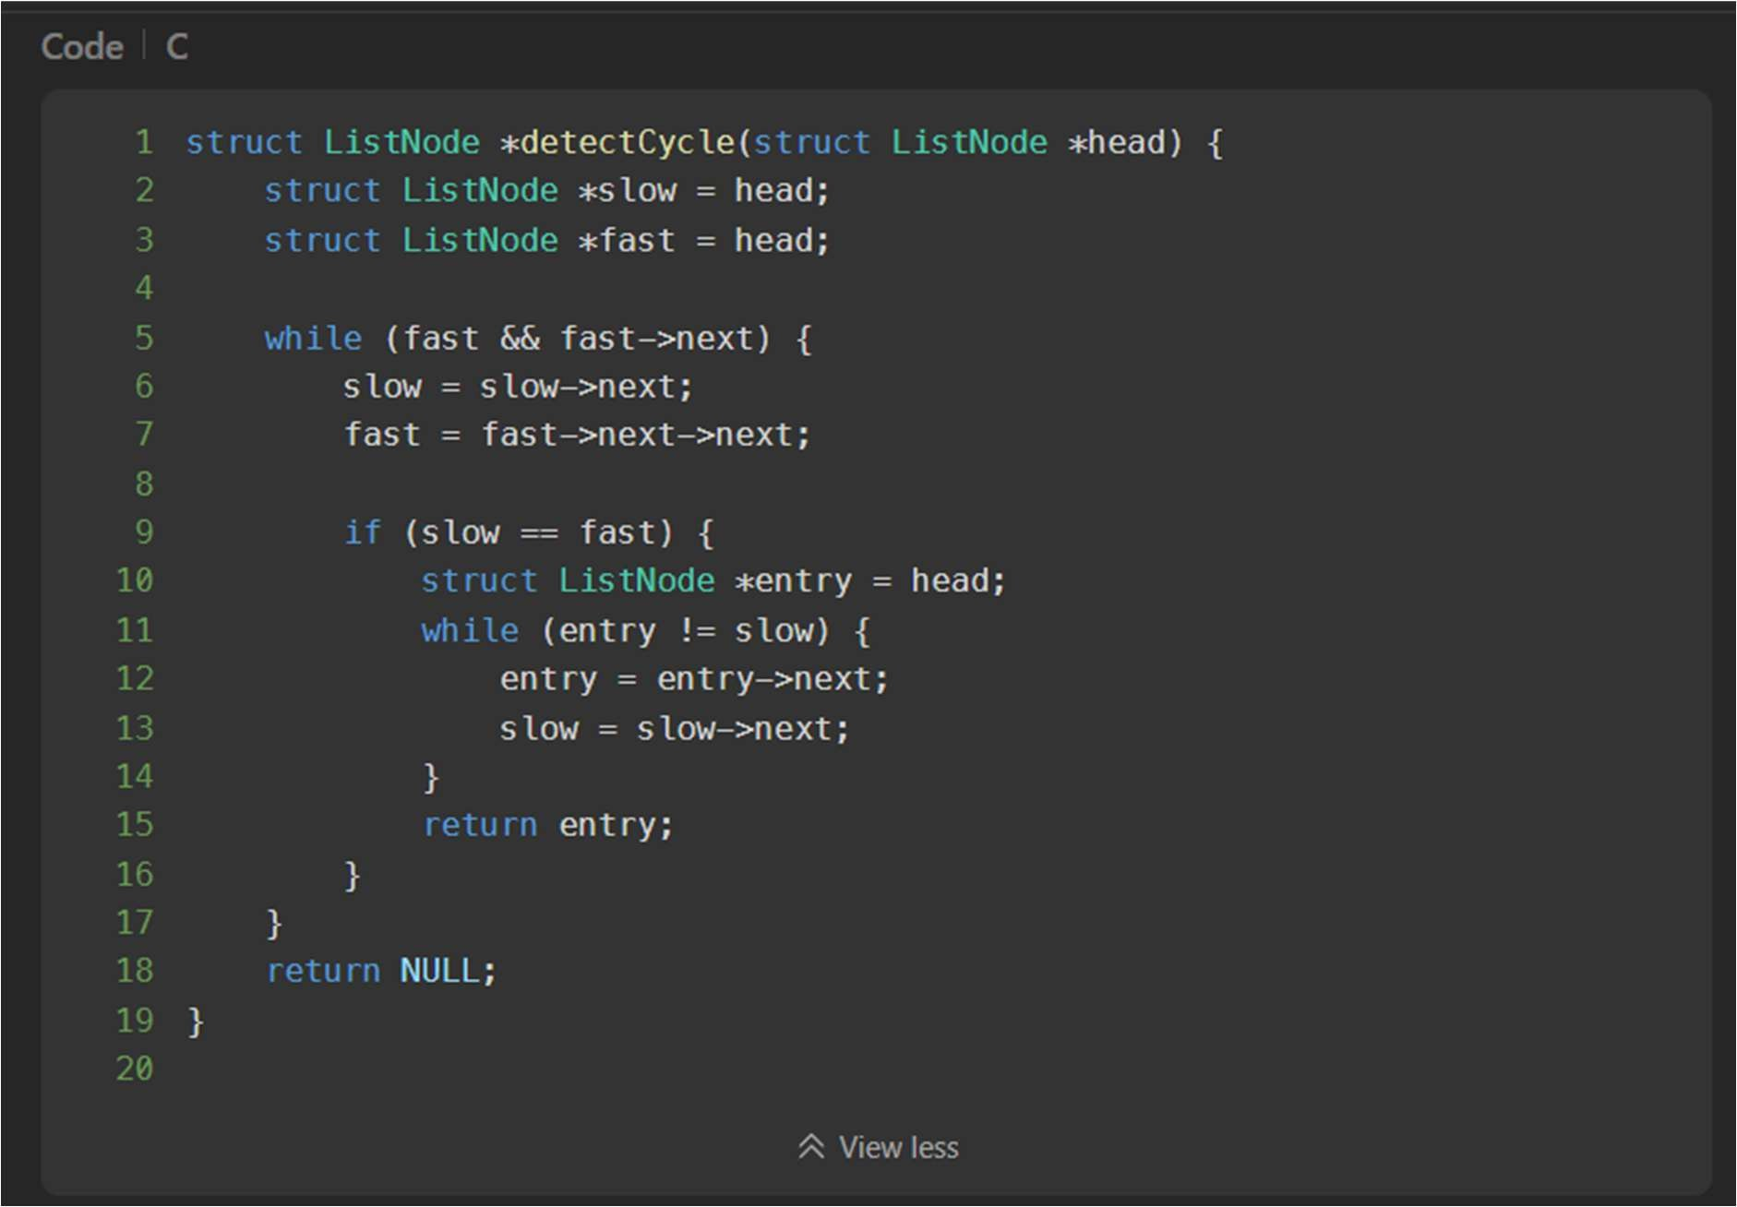

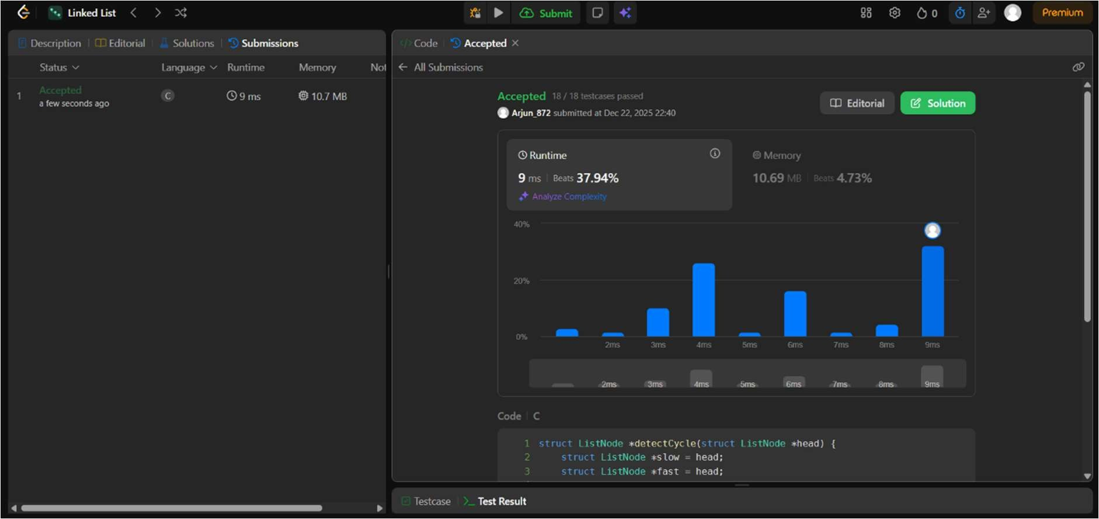

* 1. **232. Implement Queue using Stacks** Implement a first in first out (FIFO) queue using only two stacks. The implemented queue should support all the functions of a normal queue

(push, peek, pop, and empty).

Implement the MyQueue class:

* + - void push(int x) Pushes element x to the back of the queue.
    - int pop() Removes the element from the front of the queue and returns it.
    - int peek() Returns the element at the front of the queue.
    - boolean empty() Returns true if the queue is empty, false otherwise. Code:

